REST ASSIGNMENT

Assignment 1: Student Management REST API
Scenario
A college wants to create a REST API to manage student records. The frontend team has developed a React application and needs APIs to perform CRUD operations.
Requirements
- Create a Spring Boot REST project.
- Create a Student model:
  - id
  - name
  - course
  - marks
- Create REST endpoints:
  - GET /students
  - GET /students/{id}
  - POST /students
- Use @RestController.
- Test all APIs using Postman.
- Connect the API with a React UI.

Sample API Calls
GET /students
[
{
"id": 1,
"name": "Arun",
"course": "Java",
"marks": 85
}
]
GET /students/1
{
"id": 1,
"name": "Arun",
"course": "Java",
"marks": 85
}

Solution:
Structure
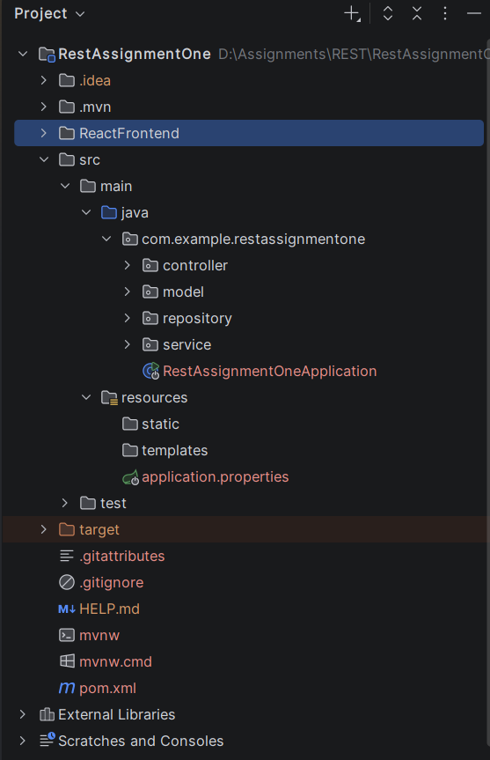
ReactFrontend UI
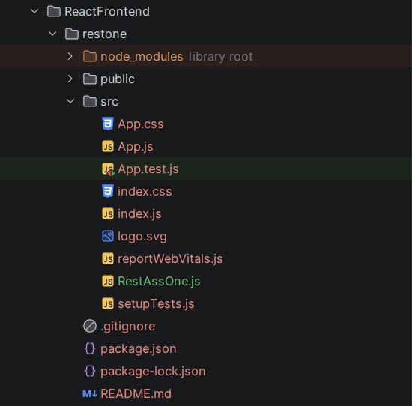

pom.xml
<?xml version="1.0" encoding="UTF-8"?>
<project xmlns="http://maven.apache.org/POM/4.0.0" xmlns:xsi="http://www.w3.org/2001/XMLSchema-instance"
xsi:schemaLocation="http://maven.apache.org/POM/4.0.0 https://maven.apache.org/xsd/maven-4.0.0.xsd">
<modelVersion>4.0.0</modelVersion>
<parent>
<groupId>org.springframework.boot</groupId>
<artifactId>spring-boot-starter-parent</artifactId>
<version>4.1.0</version>
<relativePath/> <!-- lookup parent from repository -->
</parent>
<groupId>com.example</groupId>
<artifactId>RestAssignmentOne</artifactId>
<version>0.0.1-SNAPSHOT</version>
<name>RestAssignmentOne</name>
<description>RestAssignmentOne</description>
<url/>
<licenses>
<license/>
</licenses>
<developers>
<developer/>
</developers>
<scm>
<connection/>
<developerConnection/>
<tag/>
<url/>
</scm>
<properties>
<java.version>21</java.version>
</properties>
<dependencies>
<dependency>
<groupId>org.springframework.boot</groupId>
<artifactId>spring-boot-starter-data-jpa</artifactId>
</dependency>
<dependency>
<groupId>org.springframework.boot</groupId>
<artifactId>spring-boot-starter-webmvc</artifactId>
</dependency>
<dependency>
<groupId>com.mysql</groupId>
<artifactId>mysql-connector-j</artifactId>
<scope>runtime</scope>
</dependency>
<dependency>
<groupId>org.springframework.boot</groupId>
<artifactId>spring-boot-starter-data-jpa-test</artifactId>
<scope>test</scope>
</dependency>
<dependency>
<groupId>org.springframework.boot</groupId>
<artifactId>spring-boot-starter-webmvc-test</artifactId>
<scope>test</scope>
</dependency>
</dependencies>
<build>
<plugins>
<plugin>
<groupId>org.springframework.boot</groupId>
<artifactId>spring-boot-maven-plugin</artifactId>
</plugin>
</plugins>
</build>
</project>

resources/application.properties
spring.application.name=RestAssignmentOne
spring.datasource.url=jdbc:mysql://localhost:3306/collegedb
spring.datasource.username=root
spring.datasource.password=root@123
spring.datasource.driver-class-name=com.mysql.cj.jdbc.Driver
spring.jpa.hibernate.ddl-auto=update
spring.jpa.properties.hibernate.dialect=org.hibernate.dialect.MySQLDialect
spring.jpa.show-sql=true
spring.jpa.properties.hibernate.format_sql=true

model/Student.java
package com.example.restassignmentone.model;
import jakarta.persistence.*;
@Entity
@Table(name="student")
public class Student {
@Id
@GeneratedValue(strategy = GenerationType.IDENTITY)
private Long id;
private String name;
private String course;
private Integer marks;
public Student() {}
public Student(String name, String course, Integer marks) {
this.name = name;
this.course = course;
this.marks = marks;
}
public Long getId() { return id; }
public void setId(Long id) { this.id = id; }
public String getName() { return name; }
public void setName(String name) { this.name = name; }
public String getCourse() { return course; }
public void setCourse(String course) { this.course = course; }
public Integer getMarks() { return marks; }
public void setMarks(Integer marks) { this.marks = marks; }
}

controller/StudentController.java
package com.example.restassignmentone.controller;
import com.example.restassignmentone.model.Student;
import com.example.restassignmentone.service.StudentService;
import org.springframework.beans.factory.annotation.Autowired;
import org.springframework.http.HttpStatus;
import org.springframework.http.ResponseEntity;
import org.springframework.web.bind.annotation.*;
import java.util.List;
@RestController
@RequestMapping("/students")
@CrossOrigin(origins = "*")
public class StudentController {
@Autowired
private StudentService StudentServ;
@GetMapping
public List<Student> getAllStudents() {
return StudentServ.getAllStudents();
}
@GetMapping("/{id}")
public ResponseEntity<Student> getStudentById(@PathVariable Long id) {
return StudentServ.getStudentById(id)
.map(student -> ResponseEntity.ok().body(student))
.orElse(ResponseEntity.notFound().build());
}
@PostMapping
public ResponseEntity<Student> createStudent(@RequestBody Student student) {
Student savedStudent = StudentServ.saveStudent(student);
return new ResponseEntity<>(savedStudent, HttpStatus.CREATED);
}
}

service/StudentService.java
package com.example.restassignmentone.service;
import com.example.restassignmentone.model.Student;
import com.example.restassignmentone.repository.StudentRepository;
import org.springframework.beans.factory.annotation.Autowired;
import org.springframework.stereotype.Service;
import java.util.List;
import java.util.Optional;
@Service
public class StudentService {
@Autowired
private StudentRepository studentRepository;
public List<Student> getAllStudents() {
return studentRepository.findAll();
}
public Optional<Student> getStudentById(Long id) {
return studentRepository.findById(id);
}
public Student saveStudent(Student student) {
return studentRepository.save(student);
}
}

repository/StudentService.java
package com.example.restassignmentone.repository;
import com.example.restassignmentone.model.Student;
import org.springframework.data.jpa.repository.JpaRepository;
import org.springframework.stereotype.Repository;
@Repository
public interface StudentRepository extends JpaRepository<Student, Long> {
}

RestAssignmentOneApplication.java
package com.example.restassignmentone;
import org.springframework.boot.SpringApplication;
import org.springframework.boot.autoconfigure.SpringBootApplication;
@SpringBootApplication
public class RestAssignmentOneApplication {
public static void main(String[] args) {
SpringApplication.run(RestAssignmentOneApplication.class, args);
}
}

React UI: ResAssOne.js
import React, { useState, useEffect } from 'react';
const API_URL = "http://localhost:8080/students";
function RestAssOne() {
const [students, setStudents] = useState([]);
const [formData, setFormData] = useState({ name: '', course: '', marks: '' });
const [searchId, setSearchId] = useState('');
const [searchedStudent, setSearchedStudent] = useState(null);
const [searchError, setSearchError] = useState('');
useEffect(() => {
fetchAllStudents();
}, []);
const fetchAllStudents = async () => {
try {
const response = await fetch(API_URL);
if (response.ok) {
const data = await response.json();
setStudents(data);
}
} catch (error) {
console.error("Error fetching students:", error);
}
};
const handleSearchStudent = async (e) => {
e.preventDefault();
setSearchError('');
setSearchedStudent(null);
if (!searchId) return;
try {
const response = await fetch(`${API_URL}/${searchId}`);
if (response.ok) {
const data = await response.json();
setSearchedStudent(data);
} else {
setSearchError(`Student with ID ${searchId} not found.`);
}
} catch (error) {
console.error("Error searching student:", error);
console.error("Error searching student:", error);
setSearchError("Failed to fetch student details.");
}
};
const handleInputChange = (e) => {
setFormData({ ...formData, [e.target.name]: e.target.value });
};
const handleCreateStudent = async (e) => {
e.preventDefault();
try {
const response = await fetch(API_URL, {
method: 'POST',
headers: { 'Content-Type': 'application/json' },
body: JSON.stringify({
name: formData.name,
course: formData.course,
marks: parseInt(formData.marks, 10)
})
});
if (response.ok) {
setFormData({ name: '', course: '', marks: '' });
fetchAllStudents();
}
} catch (error) {
console.error("Error creating student:", error);
}
};
return (
<div style={{ padding: '24px', fontFamily: 'sans-serif', maxWidth: '800px', margin: '0 auto' }}>
<h2>REST Assignment One</h2>
<div style={{ marginBottom: '30px', padding: '16px', border: '1px solid #ddd', borderRadius: '8px' }}>
<h3>Add New Student</h3>
<form onSubmit={handleCreateStudent} style={{ display: 'flex', gap: '10px', flexWrap: 'wrap' }}>
<input
type="text"
name="name"
placeholder="Name (e.g. Arun)"
value={formData.name}
onChange={handleInputChange}
required
style={{ padding: '8px', flex: '1' }}
/>
<input
type="text"
name="course"
placeholder="Course (e.g. Java)"
value={formData.course}
onChange={handleInputChange}
required
style={{ padding: '8px', flex: '1' }}
/>
<input
type="number"
name="marks"
placeholder="Marks (e.g. 85)"
value={formData.marks}
onChange={handleInputChange}
required
style={{ padding: '8px', width: '100px' }}
/>
<button type="submit" style={{ padding: '8px 16px', cursor: 'pointer' }}>
Submit
</button>
</form>
</div>
<div style={{ marginBottom: '30px', padding: '16px', border: '1px solid #ddd', borderRadius: '8px' }}>
<h3>Search Student By ID</h3>
<form onSubmit={handleSearchStudent} style={{ display: 'flex', gap: '10px', marginBottom: '12px' }}>
<input
type="number"
placeholder="Enter Student ID"
value={searchId}
onChange={(e) => setSearchId(e.target.value)}
required
style={{ padding: '8px', width: '180px' }}
/>
<button type="submit" style={{ padding: '8px 16px', cursor: 'pointer' }}>
Search
</button>
</form>
{searchedStudent && (
<div style={{ background: '#f4f4f4', padding: '12px', borderRadius: '4px' }}>
<p style={{ margin: '4px 0' }}><strong>ID:</strong> {searchedStudent.id}</p>
<p style={{ margin: '4px 0' }}><strong>Name:</strong> {searchedStudent.name}</p>
<p style={{ margin: '4px 0' }}><strong>Course:</strong> {searchedStudent.course}</p>
<p style={{ margin: '4px 0' }}><strong>Marks:</strong> {searchedStudent.marks}</p>
</div>
)}
{searchError && <p style={{ color: 'red', margin: 0 }}>{searchError}</p>}
</div>
<div>
<h3>All Students</h3>
<table border="1" cellPadding="10" cellSpacing="0" style={{ width: '100%', borderCollapse: 'collapse' }}>
<thead>
<tr style={{ backgroundColor: '#f2f2f2' }}>
<th>ID</th>
<th>Name</th>
<th>Course</th>
<th>Marks</th>
</tr>
</thead>
<tbody>
{students.length > 0 ? (
students.map((student) => (
<tr key={student.id}>
<td>{student.id}</td>
<td>{student.name}</td>
<td>{student.course}</td>
<td>{student.marks}</td>
</tr>
))
) : (
<tr>
<td colSpan="4" style={{ textAlign: 'center' }}>No students found</td>
</tr>
)}
</tbody>
</table>
</div>
</div>
);
}
export default RestAssOne;

Output:
Database table
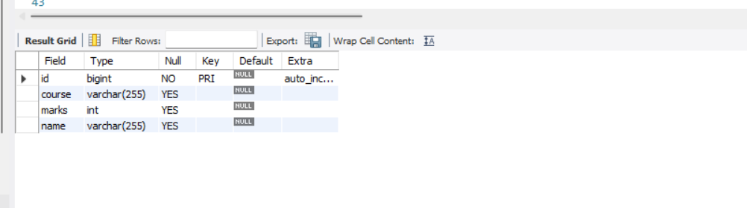
Add student
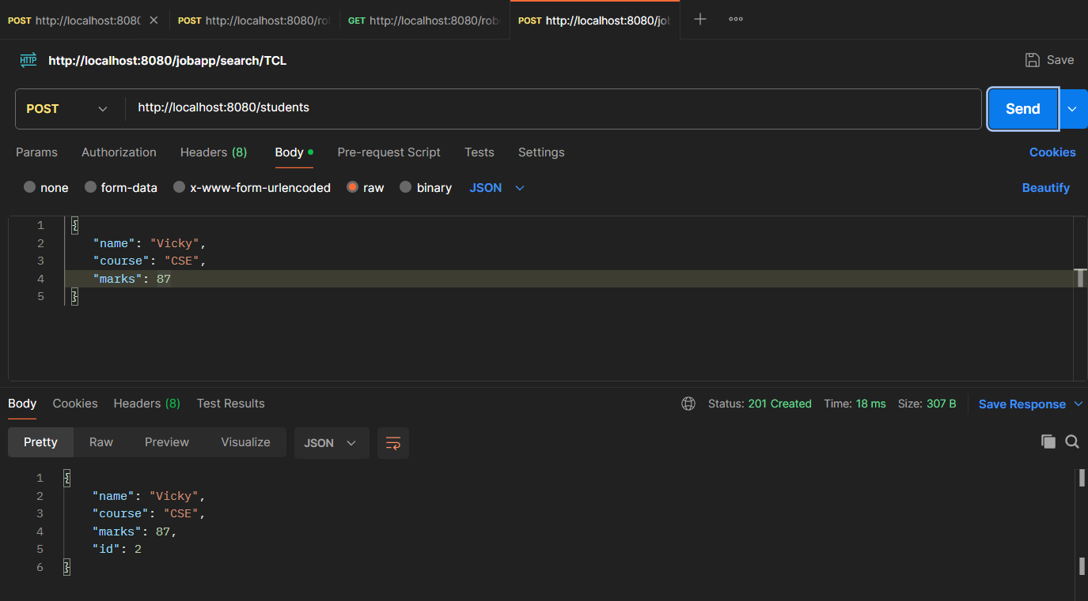

Get all Student
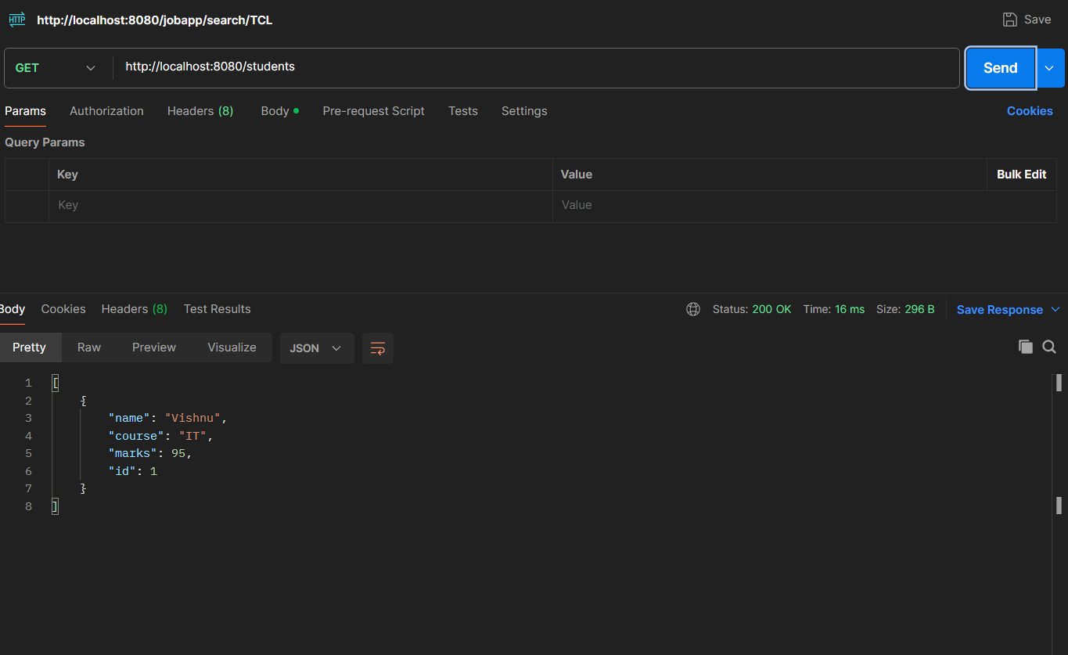
Fet by ID
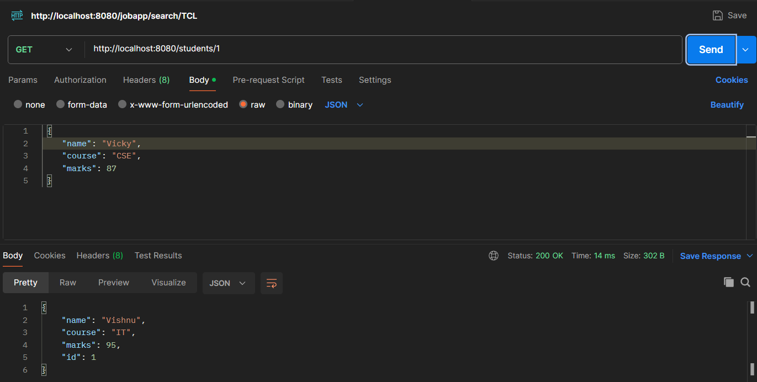

React UI
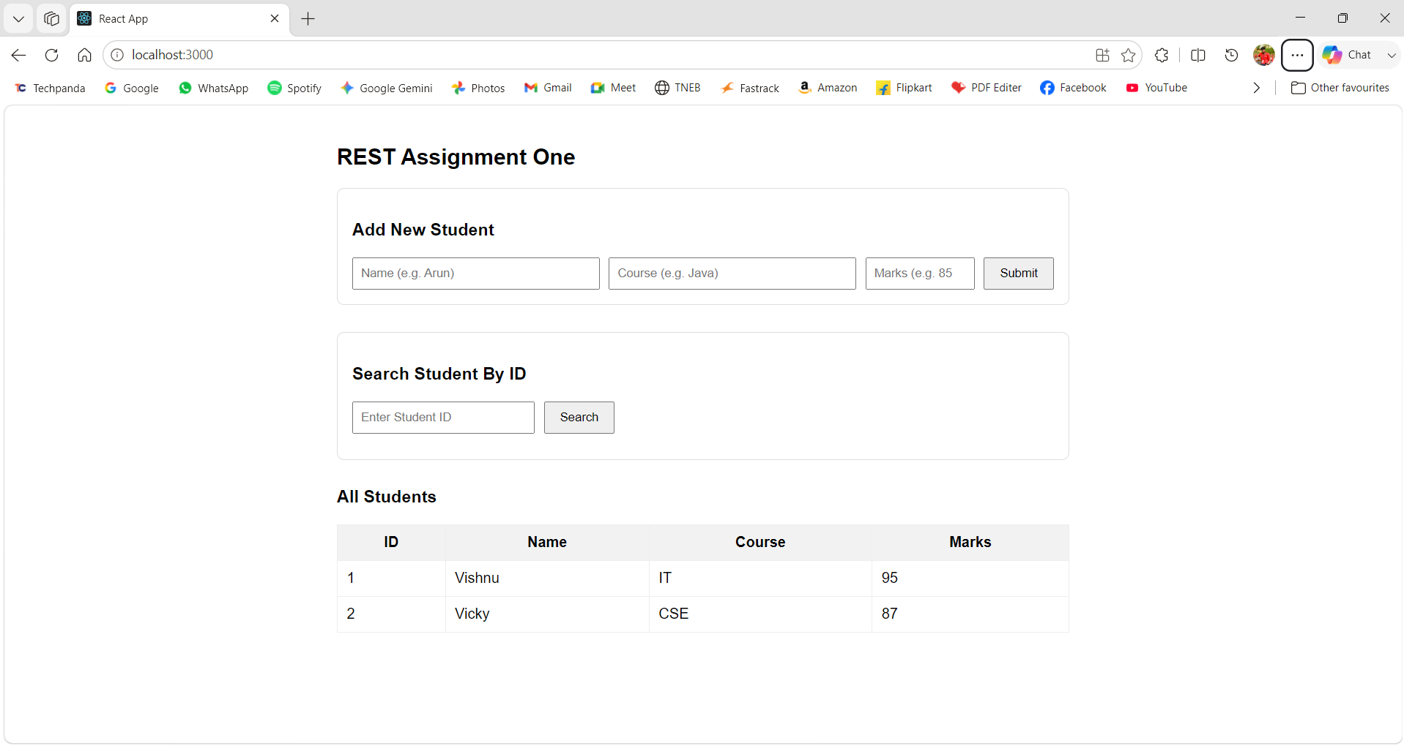

Assignment 2: Employee Directory REST API
Scenario
An HR department wants a REST service to manage employee details.
Requirements
- Create Employee Entity:
  - empId
  - empName
  - department
  - salary
- Implement:
  - GET All Employees
  - GET Employee By ID
  - POST Employee
- Use @PathVariable to fetch employee by ID.
- Test APIs using Postman.
- Display employee data in React.
Sample Output
GET /employees/101
{
"empId": 101,
"empName": "John",
"department": "IT",
"salary": 50000
}

Solution:
Structure
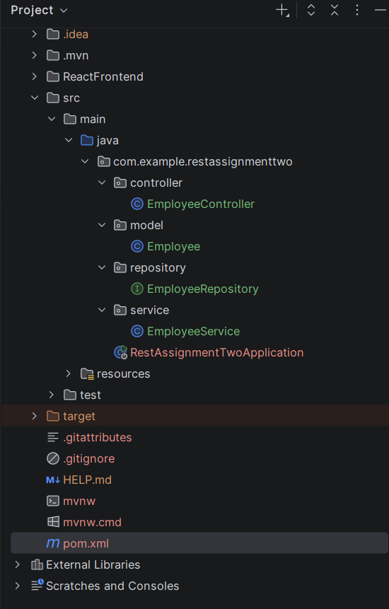
pom.xml
<?xml version="1.0" encoding="UTF-8"?>
<project xmlns="http://maven.apache.org/POM/4.0.0" xmlns:xsi="http://www.w3.org/2001/XMLSchema-instance"
xsi:schemaLocation="http://maven.apache.org/POM/4.0.0 https://maven.apache.org/xsd/maven-4.0.0.xsd">
<modelVersion>4.0.0</modelVersion>
<parent>
<groupId>org.springframework.boot</groupId>
<artifactId>spring-boot-starter-parent</artifactId>
<version>4.1.0</version>
<relativePath/> <!-- lookup parent from repository -->
</parent>
<groupId>com.example</groupId>
<artifactId>RestAssignmentTwo</artifactId>
<version>0.0.1-SNAPSHOT</version>
<name>RestAssignmentTwo</name>
<description>RestAssignmentTwo</description>
<url/>
<licenses>
<license/>
</licenses>
<developers>
<developer/>
</developers>
<scm>
<connection/>
<developerConnection/>
<tag/>
<url/>
</scm>
<properties>
<java.version>21</java.version>
</properties>
<dependencies>
<dependency>
<groupId>org.springframework.boot</groupId>
<artifactId>spring-boot-starter-data-jpa</artifactId>
</dependency>
<dependency>
<groupId>org.springframework.boot</groupId>
<artifactId>spring-boot-starter-webmvc</artifactId>
</dependency>
<dependency>
<groupId>com.mysql</groupId>
<artifactId>mysql-connector-j</artifactId>
<scope>runtime</scope>
</dependency>
<dependency>
<groupId>org.springframework.boot</groupId>
<artifactId>spring-boot-starter-data-jpa-test</artifactId>
<scope>test</scope>
</dependency>
<dependency>
<groupId>org.springframework.boot</groupId>
<artifactId>spring-boot-starter-webmvc-test</artifactId>
<scope>test</scope>
</dependency>
</dependencies>
<build>
<plugins>
<plugin>
<groupId>org.springframework.boot</groupId>
<artifactId>spring-boot-maven-plugin</artifactId>
</plugin>
</plugins>
</build>
</project>

resources/application.properties
spring.application.name=RestAssignmentTwo
spring.datasource.url=jdbc:mysql://localhost:3306/employeedb
spring.datasource.username=root
spring.datasource.password=root@123
spring.datasource.driver-class-name=com.mysql.cj.jdbc.Driver
spring.jpa.hibernate.ddl-auto=update
spring.jpa.properties.hibernate.dialect=org.hibernate.dialect.MySQLDialect
spring.jpa.show-sql=true
spring.jpa.properties.hibernate.format_sql=true

model/Employee.java
package com.example.restassignmenttwo.model;
import jakarta.persistence.Entity;
import jakarta.persistence.GeneratedValue;
import jakarta.persistence.GenerationType;
import jakarta.persistence.Id;
@Entity
public class Employee {
@Id
@GeneratedValue(strategy = GenerationType.IDENTITY)
private Long empId;
private String empName;
private String department;
private Double salary;
public Employee() {}
public Employee(String empName, String department, Double salary) {
this.empName = empName;
this.department = department;
this.salary = salary;
}
public Long getEmpId() { return empId; }
public void setEmpId(Long empId) { this.empId = empId; }
public String getEmpName() { return empName; }
public void setEmpName(String empName) { this.empName = empName; }
public String getDepartment() { return department; }
public void setDepartment(String department) { this.department = department; }
public Double getSalary() { return salary; }
public void setSalary(Double salary) { this.salary = salary; }
}

controller/EmployeeController.java
package com.example.restassignmenttwo.controller;
import com.example.restassignmenttwo.model.Employee;
import com.example.restassignmenttwo.service.EmployeeService;
import org.springframework.beans.factory.annotation.Autowired;
import org.springframework.http.HttpStatus;
import org.springframework.http.ResponseEntity;
import org.springframework.web.bind.annotation.*;
import java.util.List;
@RestController
@RequestMapping("/employees")
@CrossOrigin(origins = "*")
public class EmployeeController {
@Autowired
private EmployeeService employeeService;
@GetMapping
public List<Employee> getAllEmployees() {
return employeeService.getAllEmployees();
}
@GetMapping("/{id}")
public ResponseEntity<Employee> getEmployeeById(@PathVariable("id") Long id) {
return employeeService.getEmployeeById(id)
.map(employee -> ResponseEntity.ok().body(employee))
.orElse(ResponseEntity.notFound().build());
}
@PostMapping
public ResponseEntity<Employee> createEmployee(@RequestBody Employee employee) {
Employee savedEmployee = employeeService.saveEmployee(employee);
return new ResponseEntity<>(savedEmployee, HttpStatus.CREATED);
}
}

service/EmployeeService.java
package com.example.restassignmenttwo.service;
import com.example.restassignmenttwo.model.Employee;
import com.example.restassignmenttwo.repository.EmployeeRepository;
import org.springframework.beans.factory.annotation.Autowired;
import org.springframework.stereotype.Service;
import java.util.List;
import java.util.Optional;
@Service
public class EmployeeService {
@Autowired
private EmployeeRepository employeeRepository;
public List<Employee> getAllEmployees() {
return employeeRepository.findAll();
}
public Optional<Employee> getEmployeeById(Long id) {
return employeeRepository.findById(id);
}
public Employee saveEmployee(Employee employee) {
return employeeRepository.save(employee);
}
}

repository/EmployeeRepository.java
package com.example.restassignmenttwo.repository;
import com.example.restassignmenttwo.model.Employee;
import org.springframework.data.jpa.repository.JpaRepository;
import org.springframework.stereotype.Repository;
@Repository
public interface EmployeeRepository extends JpaRepository<Employee, Long> {
}

RestAssignmentTwoApplication.java
package com.example.restassignmenttwo;
import org.springframework.boot.SpringApplication;
import org.springframework.boot.autoconfigure.SpringBootApplication;
@SpringBootApplication
public class RestAssignmentTwoApplication {
public static void main(String[] args) {
SpringApplication.run(RestAssignmentTwoApplication.class, args);
}
}

React UI: RestAssTwo.js
import React, { useState, useEffect } from 'react';
const API_URL = "http://localhost:8080/employees";
function RestAssTwo() {
const [employees, setEmployees] = useState([]);
const [formData, setFormData] = useState({ empName: '', department: '', salary: '' });
const [searchId, setSearchId] = useState('');
const [searchedEmployee, setSearchedEmployee] = useState(null);
const [searchError, setSearchError] = useState('');
useEffect(() => {
fetchAllEmployees();
}, []);
const fetchAllEmployees = async () => {
try {
const response = await fetch(API_URL);
if (response.ok) {
const data = await response.json();
setEmployees(data);
}
} catch (error) {
console.error("Error fetching employees:", error);
}
};
const handleSearchEmployee = async (e) => {
e.preventDefault();
setSearchError('');
setSearchedEmployee(null);
if (!searchId) return;
try {
const response = await fetch(`${API_URL}/${searchId}`);
if (response.ok) {
const data = await response.json();
setSearchedEmployee(data);
} else {
setSearchError(`Employee with ID ${searchId} not found.`);
}
} catch (error) {
console.error("Error searching employee:", error);
setSearchError("Failed to fetch employee details.");
}
};
const handleInputChange = (e) => {
setFormData({ ...formData, [e.target.name]: e.target.value });
};
const handleCreateEmployee = async (e) => {
e.preventDefault();
try {
const response = await fetch(API_URL, {
method: 'POST',
headers: { 'Content-Type': 'application/json' },
body: JSON.stringify({
empName: formData.empName,
department: formData.department,
salary: parseFloat(formData.salary)
})
});
if (response.ok) {
setFormData({ empName: '', department: '', salary: '' });
fetchAllEmployees();
}
} catch (error) {
console.error("Error creating employee:", error);
}
};
return (
<div style={{ padding: '24px', fontFamily: 'sans-serif', maxWidth: '800px', margin: '0 auto' }}>
<h2>REST API (Assignment 2)</h2>
<div style={{ marginBottom: '30px', padding: '16px', border: '1px solid #ddd', borderRadius: '8px' }}>
<h3>Add New Employee</h3>
<form onSubmit={handleCreateEmployee} style={{ display: 'flex', gap: '10px', flexWrap: 'wrap' }}>
<input
type="text"
name="empName"
placeholder="Employee Name (e.g. John)"
value={formData.empName}
onChange={handleInputChange}
required
style={{ padding: '8px', flex: '1' }}
/>
<input
type="text"
name="department"
placeholder="Department (e.g. IT)"
value={formData.department}
onChange={handleInputChange}
required
style={{ padding: '8px', flex: '1' }}
/>
<input
type="number"
name="salary"
placeholder="Salary (e.g. 50000)"
value={formData.salary}
onChange={handleInputChange}
required
style={{ padding: '8px', width: '120px' }}
/>
<button type="submit" style={{ padding: '8px 16px', cursor: 'pointer' }}>
Submit
</button>
</form>
</div>
<div style={{ marginBottom: '30px', padding: '16px', border: '1px solid #ddd', borderRadius: '8px' }}>
<h3>Search Employee By ID</h3>
<form onSubmit={handleSearchEmployee} style={{ display: 'flex', gap: '10px', marginBottom: '12px' }}>
<input
type="number"
placeholder="Enter Employee ID"
value={searchId}
onChange={(e) => setSearchId(e.target.value)}
required
style={{ padding: '8px', width: '180px' }}
/>
<button type="submit" style={{ padding: '8px 16px', cursor: 'pointer' }}>
Search
</button>
</form>
{searchedEmployee && (
<div style={{ background: '#f4f4f4', padding: '12px', borderRadius: '4px' }}>
<p style={{ margin: '4px 0' }}><strong>Emp ID:</strong> {searchedEmployee.empId}</p>
<p style={{ margin: '4px 0' }}><strong>Name:</strong> {searchedEmployee.empName}</p>
<p style={{ margin: '4px 0' }}><strong>Department:</strong> {searchedEmployee.department}</p>
<p style={{ margin: '4px 0' }}><strong>Salary:</strong> ₹{searchedEmployee.salary}</p>
</div>
)}
{searchError && <p style={{ color: 'red', margin: 0 }}>{searchError}</p>}
</div>
<div>
<h3>All Employees</h3>
<table border="1" cellPadding="10" cellSpacing="0" style={{ width: '100%', borderCollapse: 'collapse' }}>
<thead>
<tr style={{ backgroundColor: '#f2f2f2' }}>
<th>Emp ID</th>
<th>Name</th>
<th>Department</th>
<th>Salary</th>
</tr>
</thead>
<tbody>
{employees.length > 0 ? (
employees.map((emp) => (
<tr key={emp.empId}>
<td>{emp.empId}</td>
<td>{emp.empName}</td>
<td>{emp.department}</td>
<td>₹{emp.salary}</td>
</tr>
))
) : (
<tr>
<td colSpan="4" style={{ textAlign: 'center' }}>No employees found</td>
</tr>
)}
</tbody>
</table>
</div>
</div>
);
}
export default RestAssTwo;

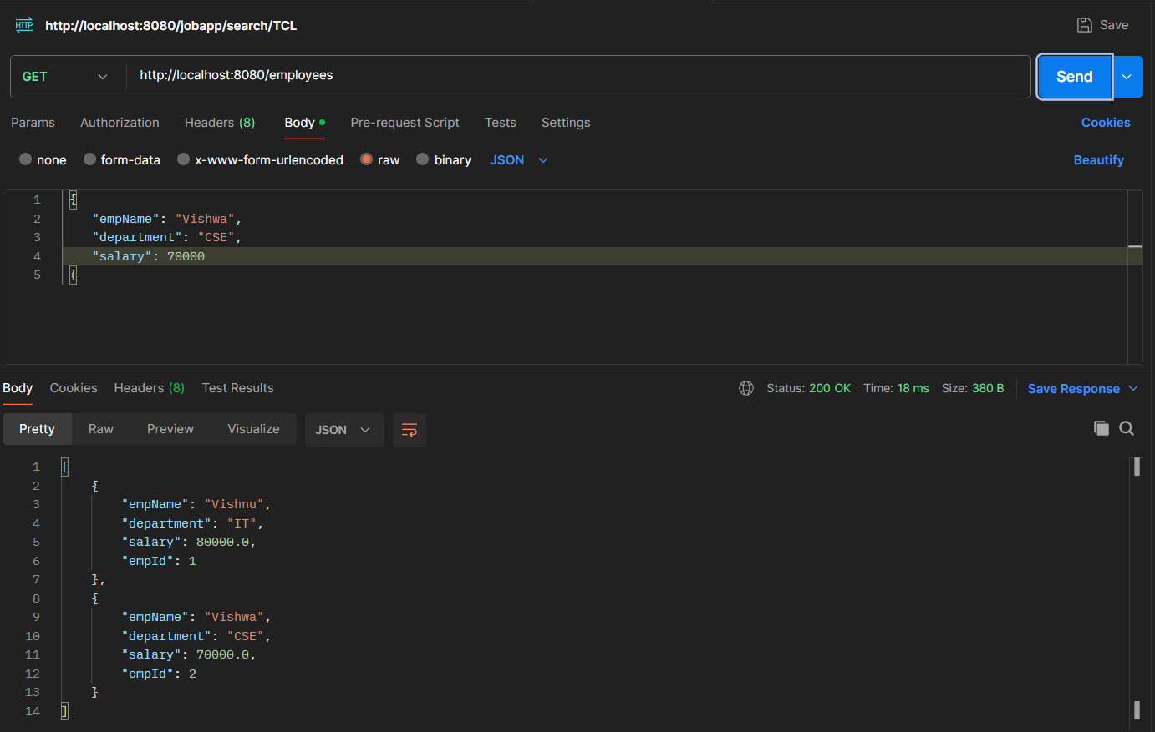
Output: 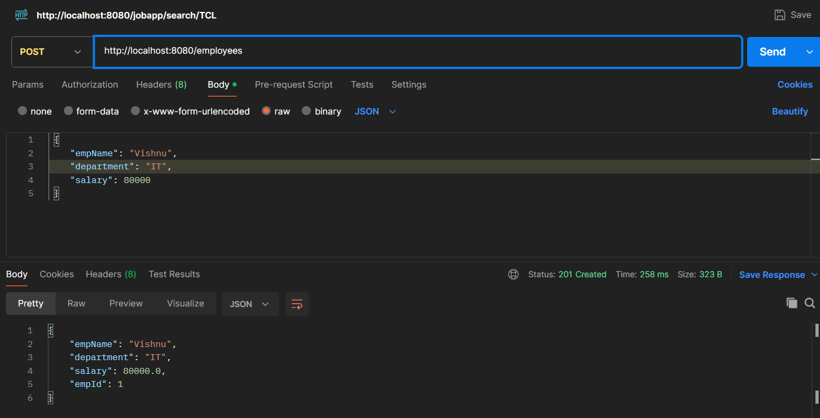 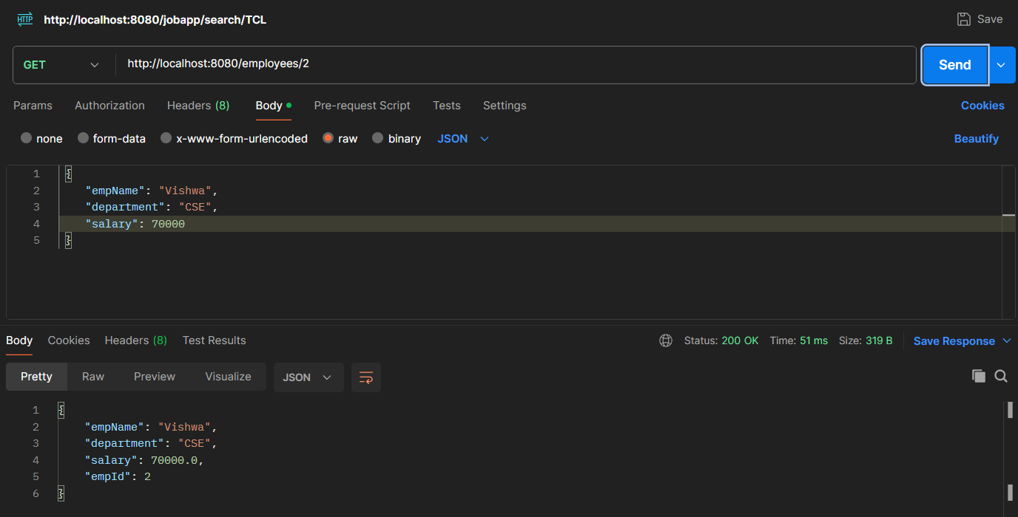

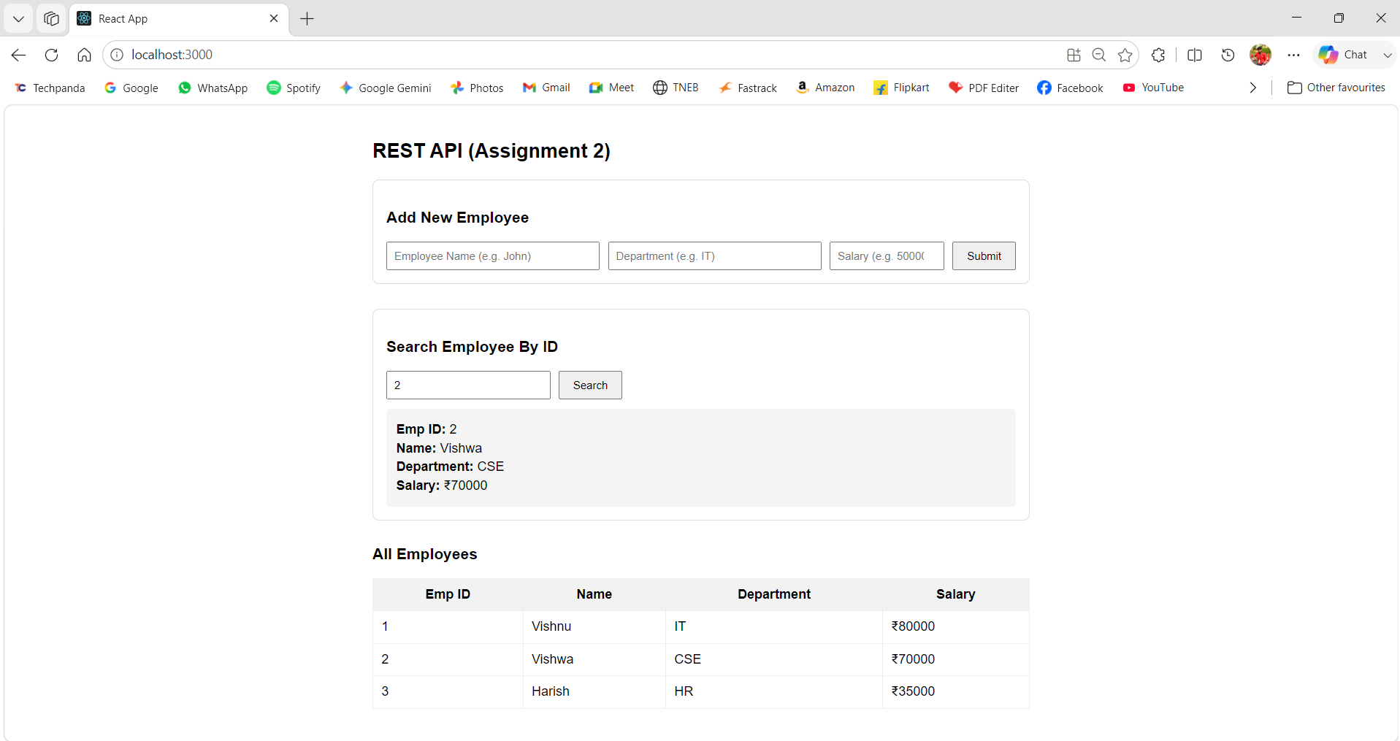
MySQL Table
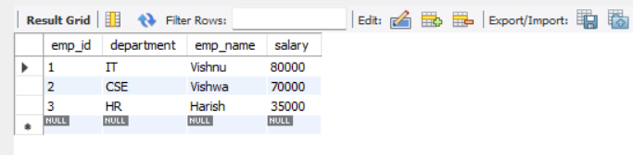
Assignment 3: Library Book Management API
Scenario
A library wants to maintain book information using REST services.
Requirements
- Create Book Entity:
  - bookId
  - title
  - author
  - category
- Create REST endpoints.
- Use PathVariable to search books.
- Test APIs using Postman.
- Display books in React UI.
Sample Output
{
"bookId": 1001,
"title": "Spring Boot Mastery",
"author": "James",
"category": "Programming"
}

Solution:
Structure
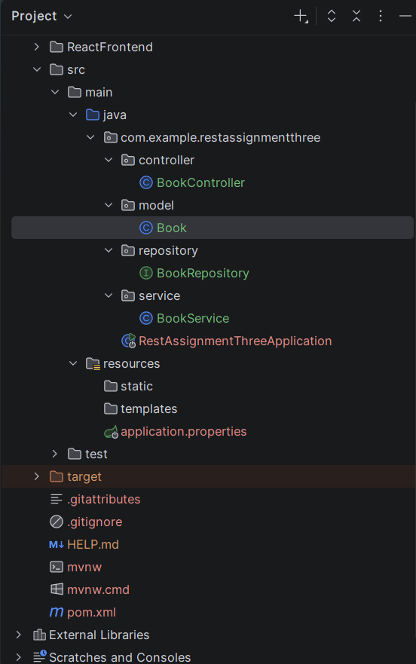
pom.xml
<?xml version="1.0" encoding="UTF-8"?>
<project xmlns="http://maven.apache.org/POM/4.0.0" xmlns:xsi="http://www.w3.org/2001/XMLSchema-instance"
xsi:schemaLocation="http://maven.apache.org/POM/4.0.0 https://maven.apache.org/xsd/maven-4.0.0.xsd">
<modelVersion>4.0.0</modelVersion>
<parent>
<groupId>org.springframework.boot</groupId>
<artifactId>spring-boot-starter-parent</artifactId>
<version>4.1.0</version>
<relativePath/> <!-- lookup parent from repository -->
</parent>
<groupId>com.example</groupId>
<artifactId>RestAssignmentThree</artifactId>
<version>0.0.1-SNAPSHOT</version>
<name>RestAssignmentThree</name>
<description>RestAssignmentThree</description>
<url/>
<licenses>
<license/>
</licenses>
<developers>
<developer/>
</developers>
<scm>
<connection/>
<developerConnection/>
<tag/>
<url/>
</scm>
<properties>
<java.version>21</java.version>
</properties>
<dependencies>
<dependency>
<groupId>org.springframework.boot</groupId>
<artifactId>spring-boot-starter-data-jpa</artifactId>
</dependency>
<dependency>
<groupId>org.springframework.boot</groupId>
<artifactId>spring-boot-starter-webmvc</artifactId>
</dependency>
<dependency>
<groupId>com.mysql</groupId>
<artifactId>mysql-connector-j</artifactId>
<scope>runtime</scope>
</dependency>
<dependency>
<groupId>org.springframework.boot</groupId>
<artifactId>spring-boot-starter-data-jpa-test</artifactId>
<scope>test</scope>
</dependency>
<dependency>
<groupId>org.springframework.boot</groupId>
<artifactId>spring-boot-starter-webmvc-test</artifactId>
<scope>test</scope>
</dependency>
</dependencies>
<build>
<plugins>
<plugin>
<groupId>org.springframework.boot</groupId>
<artifactId>spring-boot-maven-plugin</artifactId>
</plugin>
</plugins>
</build>
</project>

resources/application.properties
spring.application.name=RestAssignmentThree
spring.datasource.url=jdbc:mysql://localhost:3306/employeedb
spring.datasource.username=root
spring.datasource.password=root@123
spring.datasource.driver-class-name=com.mysql.cj.jdbc.Driver
spring.jpa.hibernate.ddl-auto=update
spring.jpa.properties.hibernate.dialect=org.hibernate.dialect.MySQLDialect
spring.jpa.show-sql=true
spring.jpa.properties.hibernate.format_sql=true

mode/book.java
package com.example.restassignmentthree.model;
import jakarta.persistence.*;
@Entity
@Table(name="book")
public class Book {
@Id
@GeneratedValue(strategy = GenerationType.IDENTITY)
private Long bookId;
private String title;
private String author;
private String category;
public Book() {}
public Book(String title, String author, String category) {
this.title = title;
this.author = author;
this.category = category;
}
public Long getBookId() { return bookId; }
public void setBookId(Long bookId) { this.bookId = bookId; }
public String getTitle() { return title; }
public void setTitle(String title) { this.title = title; }
public String getAuthor() { return author; }
public void setAuthor(String author) { this.author = author; }
public String getCategory() { return category; }
public void setCategory(String category) { this.category = category; }
}

controller/BookController.java
package com.example.restassignmentthree.controller;
import com.example.restassignmentthree.model.Book;
import com.example.restassignmentthree.service.BookService;
import org.springframework.beans.factory.annotation.Autowired;
import org.springframework.http.HttpStatus;
import org.springframework.http.ResponseEntity;
import org.springframework.web.bind.annotation.*;
import java.util.List;
@RestController
@RequestMapping("/books")
@CrossOrigin(origins = "*")
public class BookController {
@Autowired
private BookService bookService;
@GetMapping
public List<Book> getAllBooks() {
return bookService.getAllBooks();
}
@GetMapping("/{id}")
public ResponseEntity<Book> getBookById(@PathVariable("id") Long id) {
return bookService.getBookById(id)
.map(book -> ResponseEntity.ok().body(book))
.orElse(ResponseEntity.notFound().build());
}
@PostMapping
public ResponseEntity<Book> createBook(@RequestBody Book book) {
Book savedBook = bookService.saveBook(book);
return new ResponseEntity<>(savedBook, HttpStatus.CREATED);
}
}

service/BookService.java
package com.example.restassignmentthree.service;
import com.example.restassignmentthree.model.Book;
import com.example.restassignmentthree.repository.BookRepository;
import org.springframework.beans.factory.annotation.Autowired;
import org.springframework.stereotype.Service;
import java.util.List;
import java.util.Optional;
@Service
public class BookService {
@Autowired
private BookRepository bookRepository;
public List<Book> getAllBooks() {
return bookRepository.findAll();
}
public Optional<Book> getBookById(Long id) {
return bookRepository.findById(id);
}
public Book saveBook(Book book) {
return bookRepository.save(book);
}
}

repository/BookRepository.java
package com.example.restassignmentthree.repository;
import com.example.restassignmentthree.model.Book;
import org.springframework.data.jpa.repository.JpaRepository;
import org.springframework.stereotype.Repository;
@Repository
public interface BookRepository extends JpaRepository<Book, Long> {
}

RestAssignmentThreeApplication.java
package com.example.restassignmentthree;
import org.springframework.boot.SpringApplication;
import org.springframework.boot.autoconfigure.SpringBootApplication;
@SpringBootApplication
public class RestAssignmentThreeApplication {
public static void main(String[] args) {
SpringApplication.run(RestAssignmentThreeApplication.class, args);
}
}

React UI: RestAssThree.js
import React, { useState, useEffect } from 'react';
const API_URL = "http://localhost:8080/books";
function RestAssThree() {
const [books, setBooks] = useState([]);
const [formData, setFormData] = useState({ title: '', author: '', category: '' });
const [searchId, setSearchId] = useState('');
const [searchedBook, setSearchedBook] = useState(null);
const [searchError, setSearchError] = useState('');
useEffect(() => {
fetchAllBooks();
}, []);
const fetchAllBooks = async () => {
try {
const response = await fetch(API_URL);
if (response.ok) {
const data = await response.json();
setBooks(data);
}
} catch (error) {
console.error("Error fetching books:", error);
}
};
const handleSearchBook = async (e) => {
e.preventDefault();
setSearchError('');
setSearchedBook(null);
if (!searchId) return;
try {
const response = await fetch(`${API_URL}/${searchId}`);
if (response.ok) {
const data = await response.json();
setSearchedBook(data);
} else {
setSearchError(`Book with ID ${searchId} not found.`);
}
} catch (error) {
console.error("Error searching book:", error);
setSearchError("Failed to fetch book details.");
}
};
const handleInputChange = (e) => {
setFormData({ ...formData, [e.target.name]: e.target.value });
};
const handleCreateBook = async (e) => {
e.preventDefault();
try {
const response = await fetch(API_URL, {
method: 'POST',
headers: { 'Content-Type': 'application/json' },
body: JSON.stringify({
title: formData.title,
author: formData.author,
category: formData.category
})
});
if (response.ok) {
setFormData({ title: '', author: '', category: '' });
fetchAllBooks();
}
} catch (error) {
console.error("Error adding book:", error);
}
};
return (
<div style={{ padding: '24px', fontFamily: 'sans-serif', maxWidth: '800px', margin: '0 auto' }}>
<h2>Library Book Management API (Assignment 3)</h2>
<div style={{ marginBottom: '30px', padding: '16px', border: '1px solid #ddd', borderRadius: '8px' }}>
<h3>Add New Book</h3>
<form onSubmit={handleCreateBook} style={{ display: 'flex', gap: '10px', flexWrap: 'wrap' }}>
<input
type="text"
name="title"
placeholder="Book Title (e.g. Spring Boot Mastery)"
value={formData.title}
onChange={handleInputChange}
required
style={{ padding: '8px', flex: '1' }}
/>
<input
type="text"
name="author"
placeholder="Author (e.g. James)"
value={formData.author}
onChange={handleInputChange}
required
style={{ padding: '8px', flex: '1' }}
/>
<input
type="text"
name="category"
placeholder="Category (e.g. Programming)"
value={formData.category}
onChange={handleInputChange}
required
style={{ padding: '8px', flex: '1' }}
/>
<button type="submit" style={{ padding: '8px 16px', cursor: 'pointer' }}>
Submit
</button>
</form>
</div>
<div style={{ marginBottom: '30px', padding: '16px', border: '1px solid #ddd', borderRadius: '8px' }}>
<h3>Search Book By ID</h3>
<form onSubmit={handleSearchBook} style={{ display: 'flex', gap: '10px', marginBottom: '12px' }}>
<input
type="number"
placeholder="Enter Book ID"
value={searchId}
onChange={(e) => setSearchId(e.target.value)}
required
style={{ padding: '8px', width: '180px' }}
/>
<button type="submit" style={{ padding: '8px 16px', cursor: 'pointer' }}>
Search
</button>
</form>
{searchedBook && (
<div style={{ background: '#f4f4f4', padding: '12px', borderRadius: '4px' }}>
<p style={{ margin: '4px 0' }}><strong>Book ID:</strong> {searchedBook.bookId}</p>
<p style={{ margin: '4px 0' }}><strong>Title:</strong> {searchedBook.title}</p>
<p style={{ margin: '4px 0' }}><strong>Author:</strong> {searchedBook.author}</p>
<p style={{ margin: '4px 0' }}><strong>Category:</strong> {searchedBook.category}</p>
</div>
)}
{searchError && <p style={{ color: 'red', margin: 0 }}>{searchError}</p>}
</div>
<div>
<h3>All Library Books</h3>
<table border="1" cellPadding="10" cellSpacing="0" style={{ width: '100%', borderCollapse: 'collapse' }}>
<thead>
<tr style={{ backgroundColor: '#f2f2f2' }}>
<th>Book ID</th>
<th>Title</th>
<th>Author</th>
<th>Category</th>
</tr>
</thead>
<tbody>
{books.length > 0 ? (
books.map((book) => (
<tr key={book.bookId}>
<td>{book.bookId}</td>
<td>{book.title}</td>
<td>{book.author}</td>
<td>{book.category}</td>
</tr>
))
) : (
<tr>
<td colSpan="4" style={{ textAlign: 'center' }}>No books found</td>
</tr>
)}
</tbody>
</table>
</div>
</div>
);
}
export default RestAssThree;

Output:

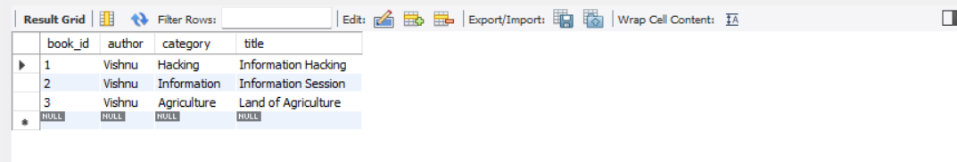

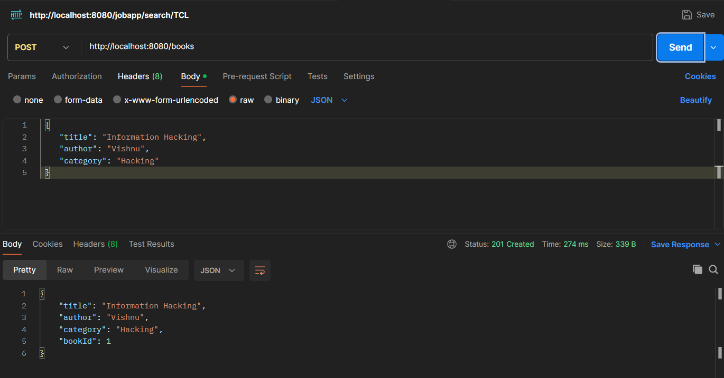

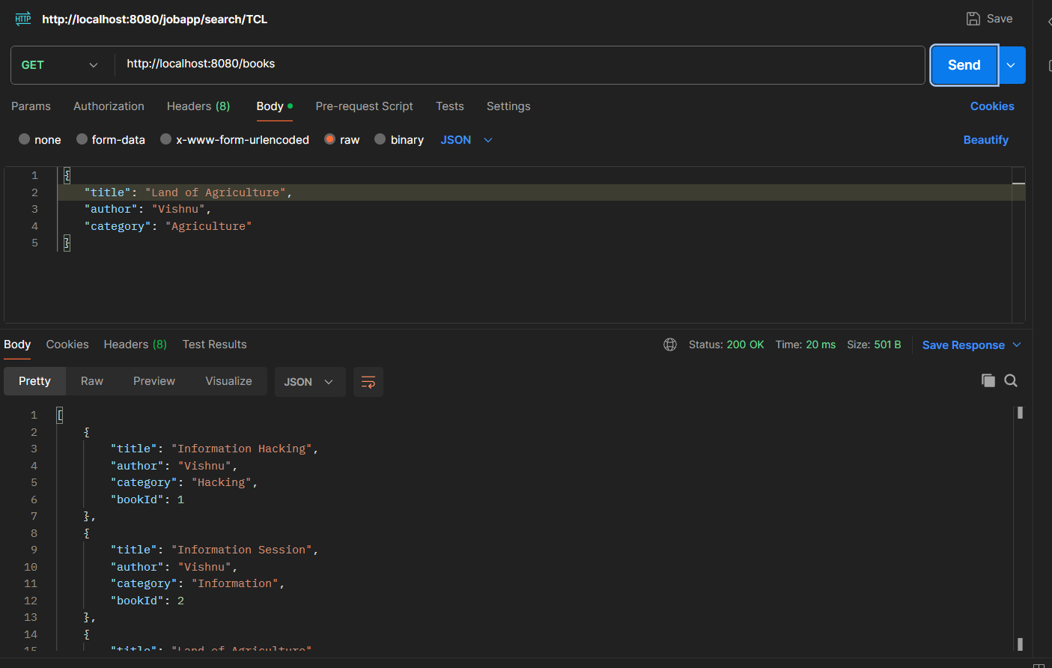

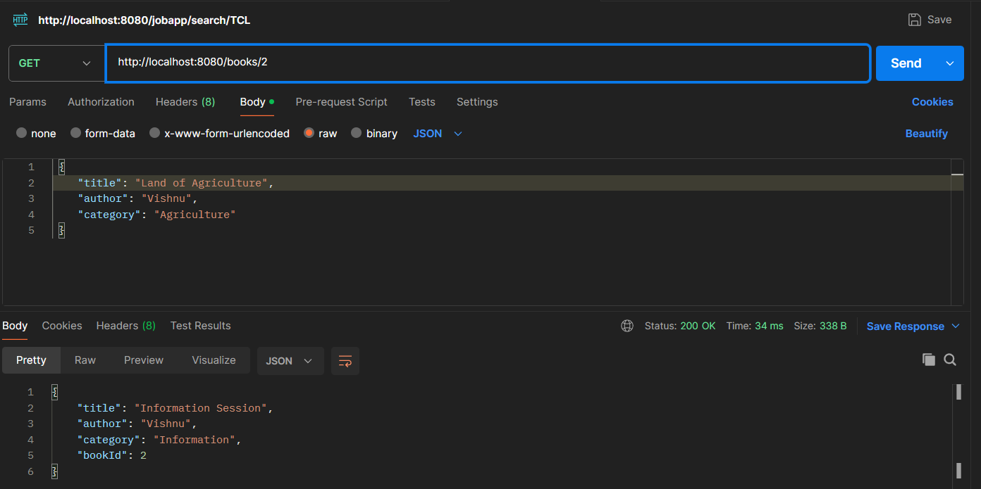

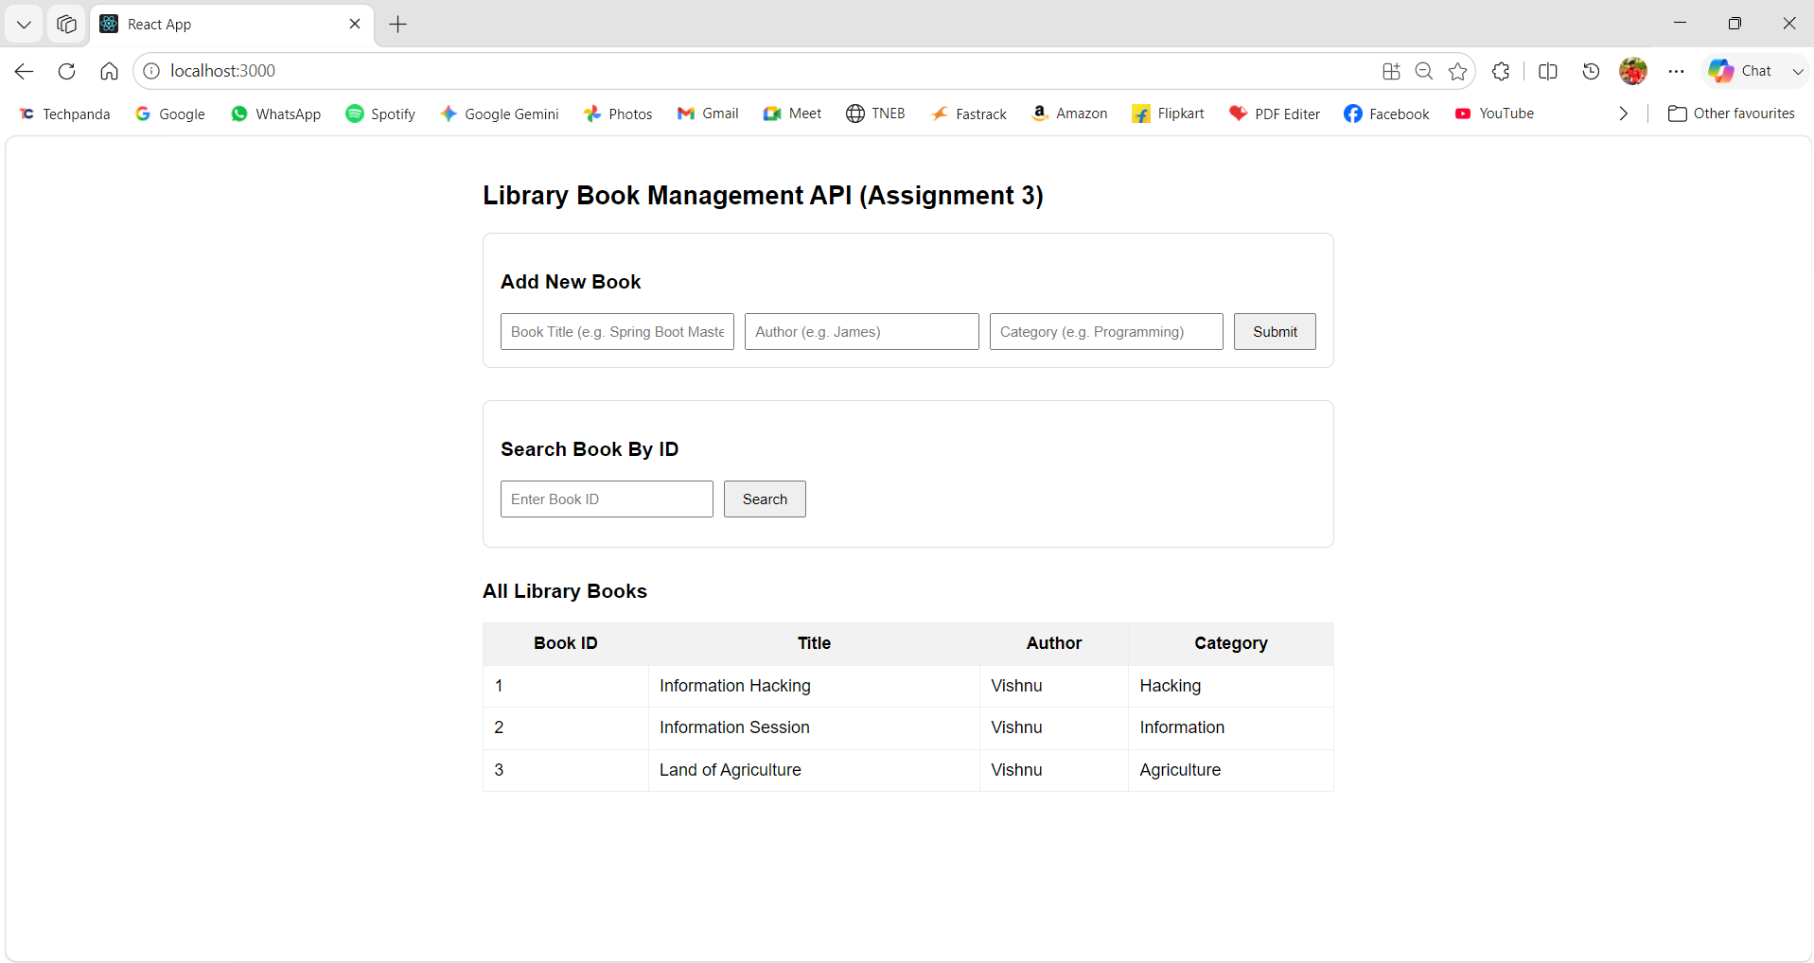

REST Using Spring Boot – Part 2 (RequestBody, PUT, DELETE, Content Negotiation)

Assignment 4: Customer Management API
Scenario
A bank wants to manage customer information through REST APIs.
Requirements
- Create Customer Entity:
  - customerId
  - customerName
  - city
  - mobileNumber
- Implement:
  - POST Customer (@RequestBody)
  - PUT Customer Update
  - DELETE Customer
- Test using Postman.
Sample Request
{
"customerName": "Rahul",
"city": "Chennai",
"mobileNumber": "9876543210"
}
Sample Response
{
"message": "Customer Added Successfully"
}

Solution

Structure
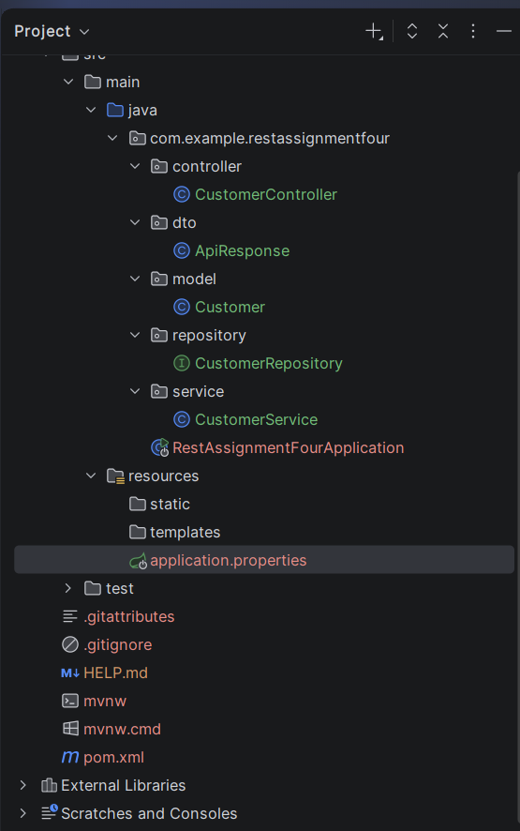
pom.xml
<?xml version="1.0" encoding="UTF-8"?>
<project xmlns="http://maven.apache.org/POM/4.0.0" xmlns:xsi="http://www.w3.org/2001/XMLSchema-instance"
xsi:schemaLocation="http://maven.apache.org/POM/4.0.0 https://maven.apache.org/xsd/maven-4.0.0.xsd">
<modelVersion>4.0.0</modelVersion>
<parent>
<groupId>org.springframework.boot</groupId>
<artifactId>spring-boot-starter-parent</artifactId>
<version>4.1.0</version>
<relativePath/> <!-- lookup parent from repository -->
</parent>
<groupId>com.example</groupId>
<artifactId>RestAssignmentFour</artifactId>
<version>0.0.1-SNAPSHOT</version>
<name>RestAssignmentFour</name>
<description>RestAssignmentFour</description>
<url/>
<licenses>
<license/>
</licenses>
<developers>
<developer/>
</developers>
<scm>
<connection/>
<developerConnection/>
<tag/>
<url/>
</scm>
<properties>
<java.version>21</java.version>
</properties>
<dependencies>
<dependency>
<groupId>org.springframework.boot</groupId>
<artifactId>spring-boot-starter-data-jpa</artifactId>
</dependency>
<dependency>
<groupId>org.springframework.boot</groupId>
<artifactId>spring-boot-starter-webmvc</artifactId>
</dependency>
<dependency>
<groupId>com.mysql</groupId>
<artifactId>mysql-connector-j</artifactId>
<scope>runtime</scope>
</dependency>
<dependency>
<groupId>org.springframework.boot</groupId>
<artifactId>spring-boot-starter-data-jpa-test</artifactId>
<scope>test</scope>
</dependency>
<dependency>
<groupId>org.springframework.boot</groupId>
<artifactId>spring-boot-starter-webmvc-test</artifactId>
<scope>test</scope>
</dependency>
</dependencies>
<build>
<plugins>
<plugin>
<groupId>org.springframework.boot</groupId>
<artifactId>spring-boot-maven-plugin</artifactId>
</plugin>
</plugins>
</build>
</project>

resources/application.properties
spring.application.name=RestAssignmentFour
spring.datasource.url=jdbc:mysql://localhost:3306/customerdb
spring.datasource.username=root
spring.datasource.password=root@123
spring.datasource.driver-class-name=com.mysql.cj.jdbc.Driver
spring.jpa.hibernate.ddl-auto=update
spring.jpa.properties.hibernate.dialect=org.hibernate.dialect.MySQLDialect
spring.jpa.show-sql=true
spring.jpa.properties.hibernate.format_sql=true

model/Customer.java
package com.example.restassignmentfour.model;
import jakarta.persistence.Entity;
import jakarta.persistence.GeneratedValue;
import jakarta.persistence.GenerationType;
import jakarta.persistence.Id;
@Entity
public class Customer {
@Id
@GeneratedValue(strategy = GenerationType.IDENTITY)
private Long customerId;
private String customerName;
private String city;
private String mobileNumber;
public Customer() {}
public Customer(String customerName, String city, String mobileNumber) {
this.customerName = customerName;
this.city = city;
this.mobileNumber = mobileNumber;
}
public Long getCustomerId() { return customerId; }
public void setCustomerId(Long customerId) { this.customerId = customerId; }
public String getCustomerName() { return customerName; }
public void setCustomerName(String customerName) { this.customerName = customerName; }
public String getCity() { return city; }
public void setCity(String city) { this.city = city; }
public String getMobileNumber() { return mobileNumber; }
public void setMobileNumber(String mobileNumber) { this.mobileNumber = mobileNumber; }
}

dto/ApiResponse.java
package com.example.restassignmentfour.dto;
public class ApiResponse {
private String message;
public ApiResponse(String message) {
this.message = message;
}
public String getMessage() { return message; }
public void setMessage(String message) { this.message = message; }
}

controller/CustomerController.java
package com.example.restassignmentfour.controller;
import com.example.restassignmentfour.dto.ApiResponse;
import com.example.restassignmentfour.model.Customer;
import com.example.restassignmentfour.service.CustomerService;
import org.springframework.beans.factory.annotation.Autowired;
import org.springframework.http.HttpStatus;
import org.springframework.http.ResponseEntity;
import org.springframework.web.bind.annotation.*;
import java.util.List;
@RestController
@RequestMapping("/customers")
@CrossOrigin(origins = "*")
public class CustomerController {
@Autowired
private CustomerService customerService;
@GetMapping
public List<Customer> getAllCustomers() {
return customerService.getAllCustomers();
}
@GetMapping("/{id}")
public ResponseEntity<?> getCustomerById(@PathVariable("id") Long id) {
return customerService.getCustomerById(id)
.map(customer -> ResponseEntity.ok().body((Object) customer))
.orElse(ResponseEntity.status(HttpStatus.NOT_FOUND)
.body(new ApiResponse("Customer with ID " + id + " not found")));
}
@PostMapping
public ResponseEntity<ApiResponse> createCustomer(@RequestBody Customer customer) {
customerService.saveCustomer(customer);
return new ResponseEntity<>(new ApiResponse("Customer Added Successfully"), HttpStatus.CREATED);
}
@PutMapping("/{id}")
public ResponseEntity<ApiResponse> updateCustomer(@PathVariable("id") Long id, @RequestBody Customer customer) {
return customerService.updateCustomer(id, customer)
.map(updated -> ResponseEntity.ok(new ApiResponse("Customer Updated Successfully")))
.orElse(ResponseEntity.status(HttpStatus.NOT_FOUND)
.body(new ApiResponse("Customer with ID " + id + " not found")));
}
@DeleteMapping("/{id}")
public ResponseEntity<ApiResponse> deleteCustomer(@PathVariable("id") Long id) {
if (customerService.deleteCustomer(id)) {
return ResponseEntity.ok(new ApiResponse("Customer Deleted Successfully"));
} else {
return ResponseEntity.status(HttpStatus.NOT_FOUND)
.body(new ApiResponse("Customer with ID " + id + " not found"));
}
}
}

service/CustomerService.java
package com.example.restassignmentfour.service;
import com.example.restassignmentfour.model.Customer;
import com.example.restassignmentfour.repository.CustomerRepository;
import org.springframework.beans.factory.annotation.Autowired;
import org.springframework.stereotype.Service;
import java.util.List;
import java.util.Optional;
@Service
public class CustomerService {
@Autowired
private CustomerRepository customerRepository;
public List<Customer> getAllCustomers() {
return customerRepository.findAll();
}
public Optional<Customer> getCustomerById(Long id) {
return customerRepository.findById(id);
}
public Customer saveCustomer(Customer customer) {
return customerRepository.save(customer);
}
public Optional<Customer> updateCustomer(Long id, Customer updatedCustomer) {
return customerRepository.findById(id).map(existingCustomer -> {
existingCustomer.setCustomerName(updatedCustomer.getCustomerName());
existingCustomer.setCity(updatedCustomer.getCity());
existingCustomer.setMobileNumber(updatedCustomer.getMobileNumber());
return customerRepository.save(existingCustomer);
});
}
public boolean deleteCustomer(Long id) {
if (customerRepository.existsById(id)) {
customerRepository.deleteById(id);
return true;
}
return false;
}
}

repository/CustomerRepository.java
package com.example.restassignmentfour.repository;
import com.example.restassignmentfour.model.Customer;
import org.springframework.data.jpa.repository.JpaRepository;
import org.springframework.stereotype.Repository;
@Repository
public interface CustomerRepository extends JpaRepository<Customer, Long> {
}

RestAssignmentFourApplication.java
package com.example.restassignmentfour;
import org.springframework.boot.SpringApplication;
import org.springframework.boot.autoconfigure.SpringBootApplication;
@SpringBootApplication
public class RestAssignmentFourApplication {
public static void main(String[] args) {
SpringApplication.run(RestAssignmentFourApplication.class, args);
}
}

React UI: RestAssFour.js
import React, { useState, useEffect } from 'react';
const API_URL = "http://localhost:8080/customers";
function RestAssFour() {
const [customers, setCustomers] = useState([]);
const [formData, setFormData] = useState({ customerName: '', city: '', mobileNumber: '' });
const [editingId, setEditingId] = useState(null);
const [statusMessage, setStatusMessage] = useState('');
// --- Search state ---
const [searchId, setSearchId] = useState('');
const [searchedCustomer, setSearchedCustomer] = useState(null);
const [searchError, setSearchError] = useState('');
useEffect(() => {
fetchAllCustomers();
}, []);
const fetchAllCustomers = async () => {
try {
const response = await fetch(API_URL);
if (response.ok) {
const data = await response.json();
setCustomers(data);
}
} catch (error) {
console.error("Error fetching customers:", error);
}
};
const handleSearchCustomer = async (e) => {
e.preventDefault();
setSearchError('');
setSearchedCustomer(null);
if (!searchId) return;
try {
const response = await fetch(`${API_URL}/${searchId}`);
if (response.ok) {
const data = await response.json();
setSearchedCustomer(data);
} else {
setSearchError(`Customer with ID ${searchId} not found.`);
}
} catch (error) {
console.error("Error searching customer:", error);
setSearchError("Failed to fetch customer details.");
}
};
const handleInputChange = (e) => {
setFormData({ ...formData, [e.target.name]: e.target.value });
};
const handleSubmit = async (e) => {
e.preventDefault();
setStatusMessage('');
const method = editingId ? 'PUT' : 'POST';
const url = editingId ? `${API_URL}/${editingId}` : API_URL;
try {
const response = await fetch(url, {
method: method,
headers: { 'Content-Type': 'application/json' },
body: JSON.stringify(formData)
});
if (response.ok) {
const data = await response.json();
setStatusMessage(data.message);
setFormData({ customerName: '', city: '', mobileNumber: '' });
setEditingId(null);
fetchAllCustomers();
}
} catch (error) {
console.error("Error submitting customer form:", error);
setStatusMessage("Operation failed. Check server log.");
}
};
const handleEdit = (customer) => {
setEditingId(customer.customerId);
setFormData({
customerName: customer.customerName,
city: customer.city,
mobileNumber: customer.mobileNumber
});
};
const handleCancelEdit = () => {
setEditingId(null);
setFormData({ customerName: '', city: '', mobileNumber: '' });
};
const handleDelete = async (id) => {
if (!window.confirm(`Are you sure you want to delete customer ID ${id}?`)) return;
try {
const response = await fetch(`${API_URL}/${id}`, {
method: 'DELETE'
});
if (response.ok) {
const data = await response.json();
setStatusMessage(data.message);
fetchAllCustomers();
}
} catch (error) {
console.error("Error deleting customer:", error);
setStatusMessage("Failed to delete customer.");
}
};
return (
<div style={{ padding: '24px', fontFamily: 'sans-serif', maxWidth: '850px', margin: '0 auto' }}>
<h2>REST API (Assignment 4)</h2>
{statusMessage && (
<div style={{ padding: '10px 16px', backgroundColor: '#e2f0d9', color: '#385723', border: '1px solid #c5e0b4', borderRadius: '4px', marginBottom: '20px' }}>
{statusMessage}
</div>
)}
<div style={{ marginBottom: '30px', padding: '16px', border: '1px solid #ddd', borderRadius: '8px' }}>
<h3>{editingId ? `Update Customer (ID: ${editingId})` : 'Add New Customer'}</h3>
<form onSubmit={handleSubmit} style={{ display: 'flex', gap: '10px', flexWrap: 'wrap' }}>
<input
type="text"
name="customerName"
placeholder="Customer Name (e.g. Vishnu)"
value={formData.customerName}
onChange={handleInputChange}
required
style={{ padding: '8px', flex: '1' }}
/>
<input
type="text"
name="city"
placeholder="City (e.g. Tindivanam)"
value={formData.city}
onChange={handleInputChange}
required
style={{ padding: '8px', flex: '1' }}
/>
<input
type="text"
name="mobileNumber"
placeholder="Mobile (e.g. 9876543210)"
value={formData.mobileNumber}
onChange={handleInputChange}
required
style={{ padding: '8px', flex: '1' }}
/>
<button type="submit" style={{ padding: '8px 16px', cursor: 'pointer', backgroundColor: editingId ? '#2196F3' : '#4CAF50', color: '#fff', border: 'none', borderRadius: '4px' }}>
{editingId ? 'Update' : 'Submit'}
</button>
{editingId && (
<button type="button" onClick={handleCancelEdit} style={{ padding: '8px 16px', cursor: 'pointer', backgroundColor: '#9e9e9e', color: '#fff', border: 'none', borderRadius: '4px' }}>
Cancel
</button>
)}
</form>
</div>
{/* --- Find By ID Section --- */}
<div style={{ marginBottom: '30px', padding: '16px', border: '1px solid #ddd', borderRadius: '8px' }}>
<h3>Search Customer By ID</h3>
<form onSubmit={handleSearchCustomer} style={{ display: 'flex', gap: '10px', marginBottom: '12px' }}>
<input
type="number"
placeholder="Enter Customer ID"
value={searchId}
onChange={(e) => setSearchId(e.target.value)}
required
style={{ padding: '8px', width: '180px' }}
/>
<button type="submit" style={{ padding: '8px 16px', cursor: 'pointer' }}>
Search
</button>
</form>
{searchedCustomer && (
<div style={{ background: '#f4f4f4', padding: '12px', borderRadius: '4px' }}>
<p style={{ margin: '4px 0' }}><strong>ID:</strong> {searchedCustomer.customerId}</p>
<p style={{ margin: '4px 0' }}><strong>Name:</strong> {searchedCustomer.customerName}</p>
<p style={{ margin: '4px 0' }}><strong>City:</strong> {searchedCustomer.city}</p>
<p style={{ margin: '4px 0' }}><strong>Mobile:</strong> {searchedCustomer.mobileNumber}</p>
</div>
)}
{searchError && <p style={{ color: 'red', margin: 0 }}>{searchError}</p>}
</div>
<div>
<h3>Customer Directory</h3>
<table border="1" cellPadding="10" cellSpacing="0" style={{ width: '100%', borderCollapse: 'collapse' }}>
<thead>
<tr style={{ backgroundColor: '#f2f2f2' }}>
<th>ID</th>
<th>Name</th>
<th>City</th>
<th>Mobile Number</th>
<th>Actions</th>
</tr>
</thead>
<tbody>
{customers.length > 0 ? (
customers.map((cust) => (
<tr key={cust.customerId}>
<td>{cust.customerId}</td>
<td>{cust.customerName}</td>
<td>{cust.city}</td>
<td>{cust.mobileNumber}</td>
<td style={{ textAlign: 'center' }}>
<button onClick={() => handleEdit(cust)} style={{ marginRight: '8px', padding: '4px 8px', cursor: 'pointer' }}>
Edit
</button>
<button onClick={() => handleDelete(cust.customerId)} style={{ padding: '4px 8px', cursor: 'pointer', color: 'red' }}>
Delete
</button>
</td>
</tr>
))
) : (
<tr>
<td colSpan="5" style={{ textAlign: 'center' }}>No customers found</td>
</tr>
)}
</tbody>
</table>
</div>
</div>
);
}
export default RestAssFour;

Output:

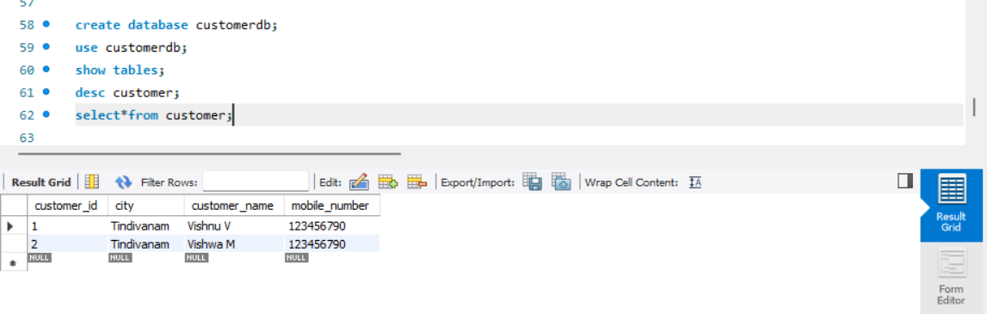

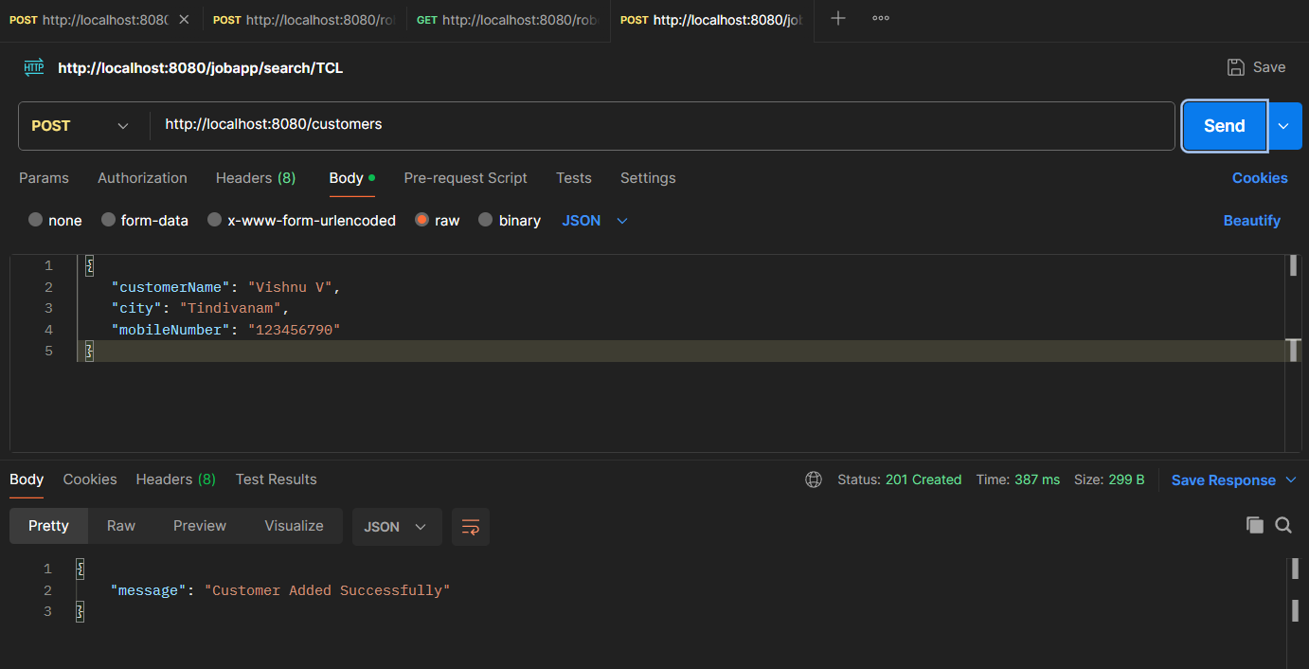

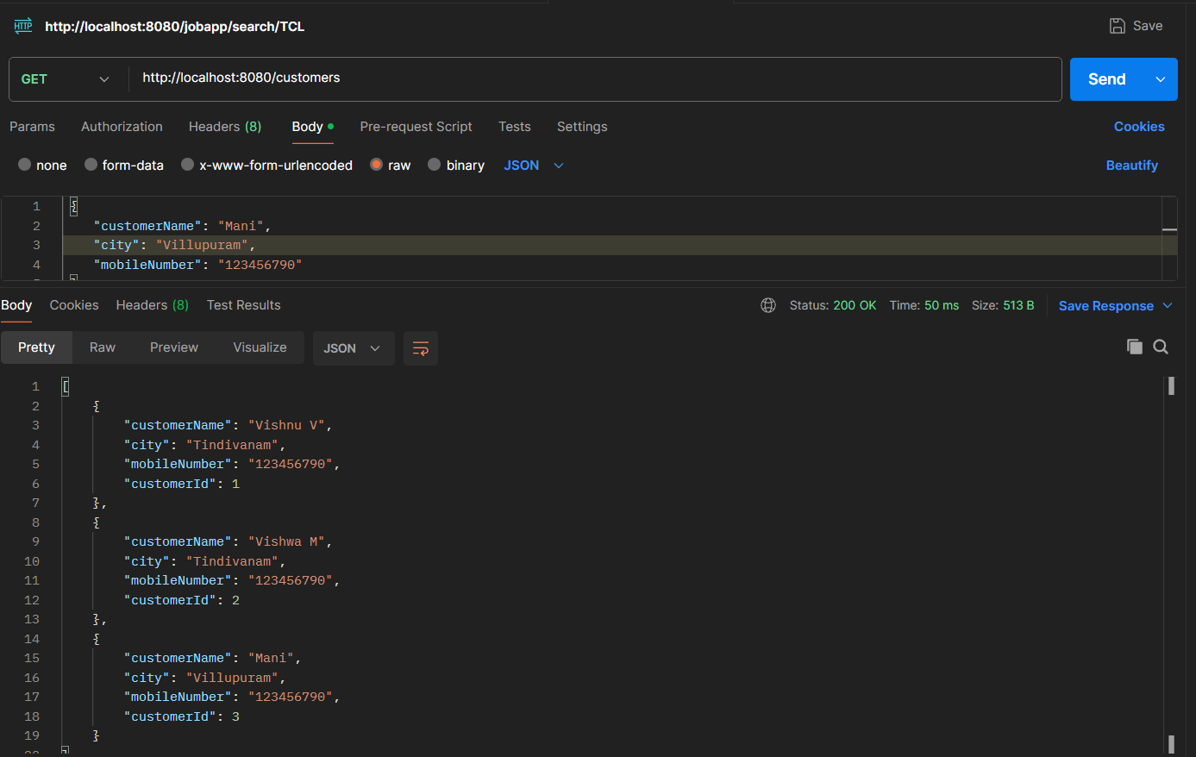

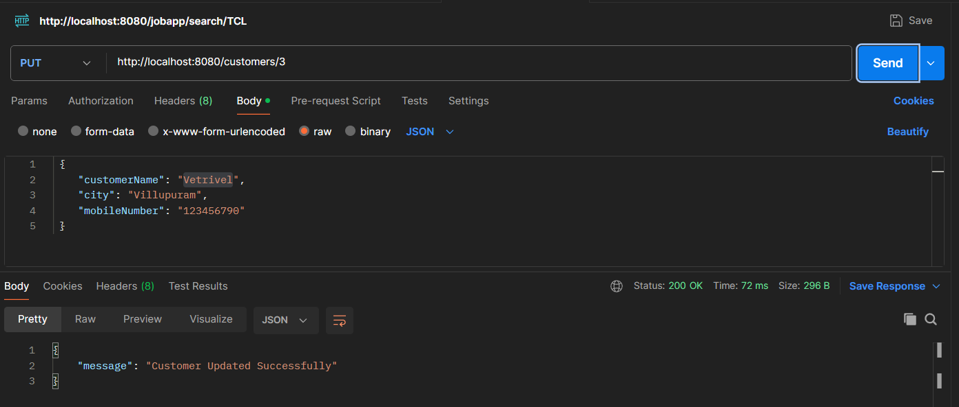

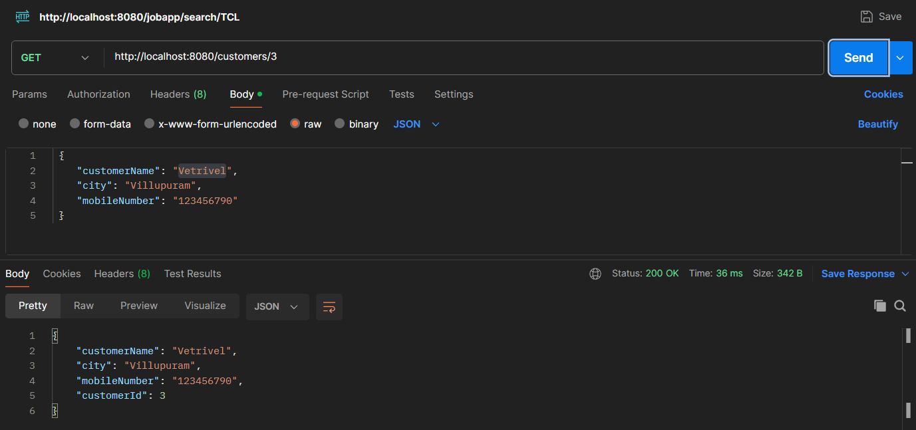

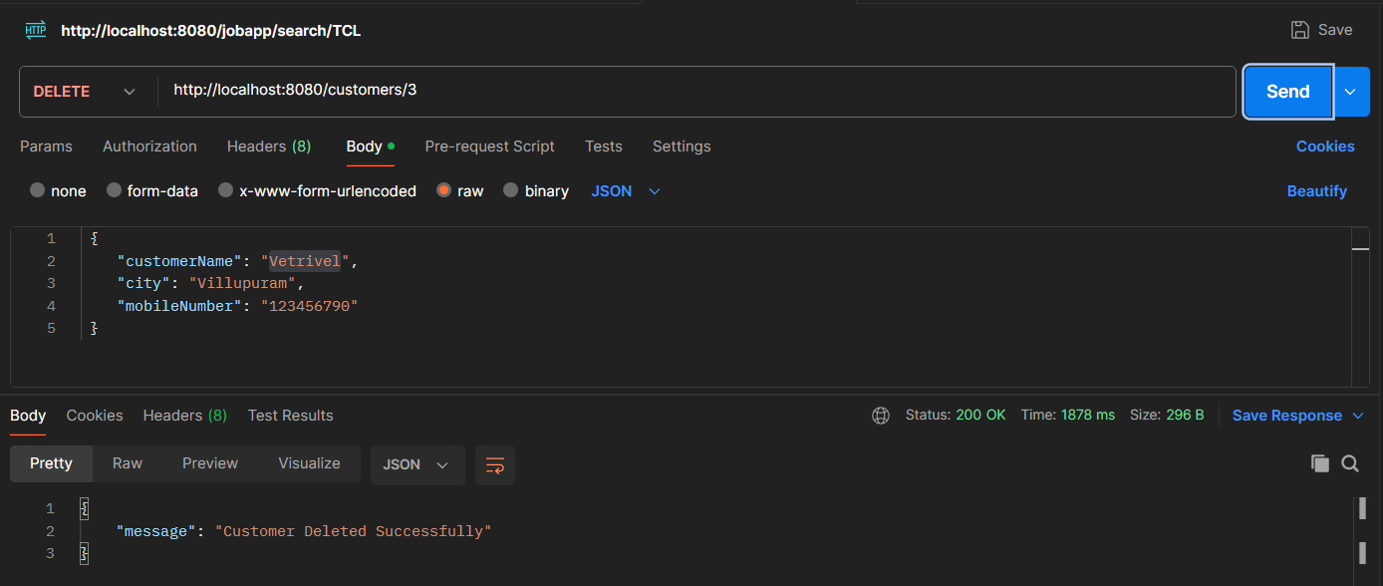

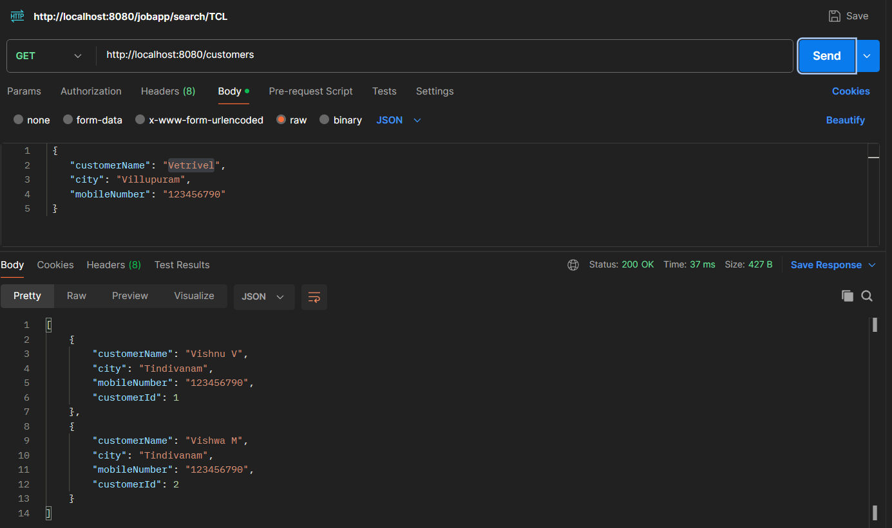

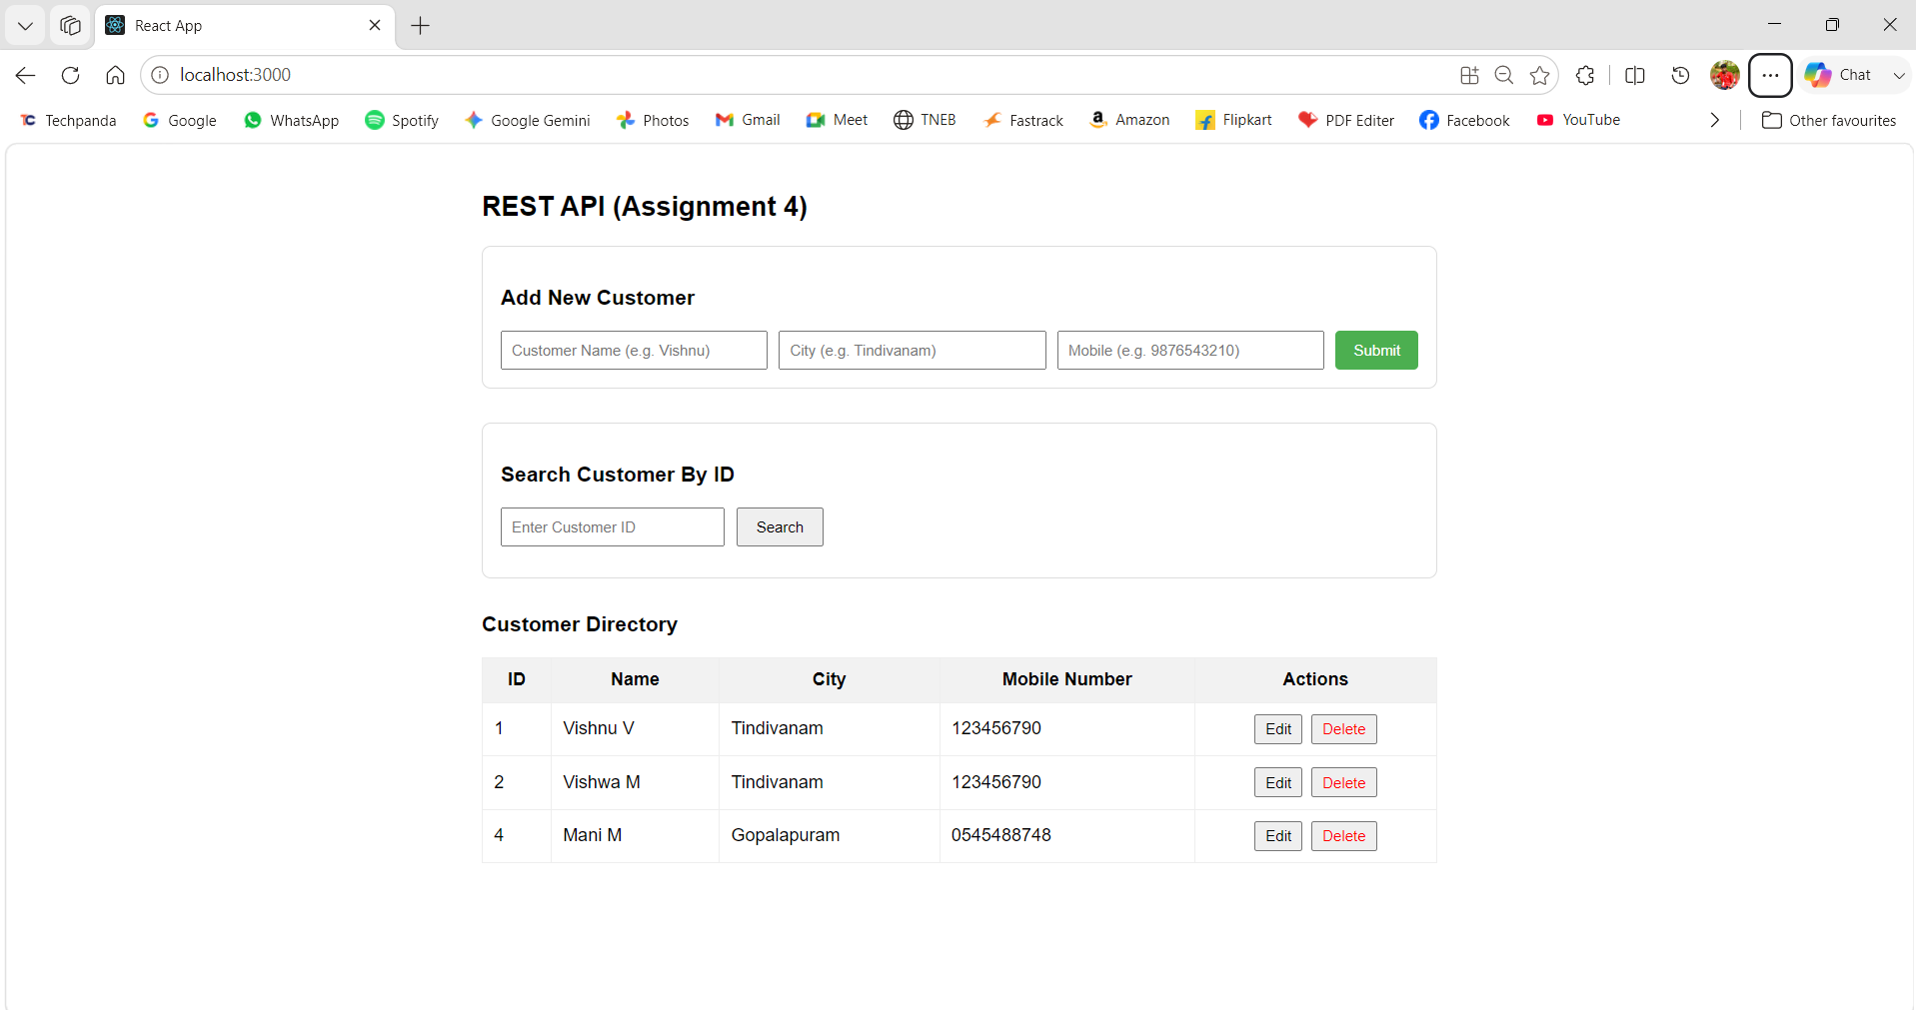

Assignment 5: Inventory Management API with Content Negotiation
Scenario
A warehouse system needs product data in both JSON and XML formats.
Requirements
- Create Product Entity.
- Configure Content Negotiation.
- Return:
  - JSON response
  - XML response
- Test using Postman Accept Headers:
  - application/json
  - application/xml
Sample JSON Output
{
"productId": 1,
"productName": "Laptop",
"price": 55000
}
Sample XML Output
<Product>
<productId>1</productId>
<productName>Laptop</productName>
<price>55000</price>
</Product>

Solution:
Structure
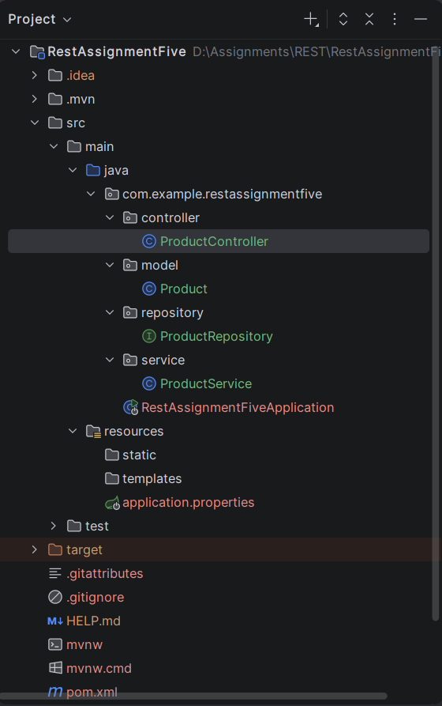
pom.xml
<?xml version="1.0" encoding="UTF-8"?>
<project xmlns="http://maven.apache.org/POM/4.0.0" xmlns:xsi="http://www.w3.org/2001/XMLSchema-instance"
xsi:schemaLocation="http://maven.apache.org/POM/4.0.0 https://maven.apache.org/xsd/maven-4.0.0.xsd">
<modelVersion>4.0.0</modelVersion>
<parent>
<groupId>org.springframework.boot</groupId>
<artifactId>spring-boot-starter-parent</artifactId>
<version>4.1.0</version>
<relativePath/> <!-- lookup parent from repository -->
</parent>
<groupId>com.example</groupId>
<artifactId>RestAssignmentFive</artifactId>
<version>0.0.1-SNAPSHOT</version>
<name>RestAssignmentFive</name>
<description>RestAssignmentFive</description>
<url/>
<licenses>
<license/>
</licenses>
<developers>
<developer/>
</developers>
<scm>
<connection/>
<developerConnection/>
<tag/>
<url/>
</scm>
<properties>
<java.version>21</java.version>
</properties>
<dependencies>
<dependency>
<groupId>org.springframework.boot</groupId>
<artifactId>spring-boot-starter-data-jpa</artifactId>
</dependency>
<dependency>
<groupId>org.springframework.boot</groupId>
<artifactId>spring-boot-starter-webmvc</artifactId>
</dependency>
<dependency>
<groupId>com.mysql</groupId>
<artifactId>mysql-connector-j</artifactId>
<scope>runtime</scope>
</dependency>
<dependency>
<groupId>org.springframework.boot</groupId>
<artifactId>spring-boot-starter-data-jpa-test</artifactId>
<scope>test</scope>
</dependency>
<dependency>
<groupId>org.springframework.boot</groupId>
<artifactId>spring-boot-starter-webmvc-test</artifactId>
<scope>test</scope>
</dependency>
<!-- Source: https://mvnrepository.com/artifact/tools.jackson.dataformat/jackson-dataformat-xml -->
<dependency>
<groupId>tools.jackson.dataformat</groupId>
<artifactId>jackson-dataformat-xml</artifactId>
<version>3.2.1</version>
<scope>compile</scope>
</dependency>
<!-- Source: https://mvnrepository.com/artifact/jakarta.xml.bind/jakarta.xml.bind-api -->
<dependency>
<groupId>jakarta.xml.bind</groupId>
<artifactId>jakarta.xml.bind-api</artifactId>
<version>4.0.5</version>
<scope>compile</scope>
</dependency>
</dependencies>
<build>
<plugins>
<plugin>
<groupId>org.springframework.boot</groupId>
<artifactId>spring-boot-maven-plugin</artifactId>
</plugin>
</plugins>
</build>
</project>

resources/application.properties
spring.application.name=RestAssignmentFive
spring.datasource.url=jdbc:mysql://localhost:3306/productdb
spring.datasource.username=root
spring.datasource.password=root@123
spring.datasource.driver-class-name=com.mysql.cj.jdbc.Driver
spring.jpa.hibernate.ddl-auto=update
spring.jpa.properties.hibernate.dialect=org.hibernate.dialect.MySQLDialect
spring.jpa.show-sql=true
spring.jpa.properties.hibernate.format_sql=true

controller/ProductController.java
package com.example.restassignmentfive.controller;
import com.example.restassignmentfive.model.Product;
import com.example.restassignmentfive.service.ProductService;
import org.springframework.beans.factory.annotation.Autowired;
import org.springframework.http.HttpStatus;
import org.springframework.http.ResponseEntity;
import org.springframework.web.bind.annotation.*;
import java.util.List;
@RestController
@RequestMapping("/products")
public class ProductController {
@Autowired
private ProductService productService;
@PostMapping(
consumes = {"application/json", "application/xml"},
produces = {"application/json", "application/xml"}
)
public ResponseEntity<Product> createProduct(@RequestBody Product product) {
Product savedProduct = productService.saveProduct(product);
return new ResponseEntity<>(savedProduct, HttpStatus.CREATED);
}
@GetMapping(
value = "/{id}",
produces = {"application/json", "application/xml"}
)
public ResponseEntity<Product> getProductById(@PathVariable("id") Long id) {
return productService.getProductById(id)
.map(product -> ResponseEntity.ok().body(product))
.orElse(ResponseEntity.notFound().build());
}
@GetMapping(produces = {"application/xml","application/json"})
public List<Product> getAllProducts() {
return productService.getAllProducts();
}
}

model/Product.java
package com.example.restassignmentfive.model;
import jakarta.persistence.*;
import jakarta.xml.bind.annotation.XmlRootElement;
@Entity
@Table(name="products")
@XmlRootElement(name = "Product")
public class Product {
@Id
@GeneratedValue(strategy = GenerationType.IDENTITY)
private Long productId;
private String productName;
private Double price;
public Product() {}
public Product(String productName, Double price) {
this.productName = productName;
this.price = price;
}
public Long getProductId() { return productId; }
public void setProductId(Long productId) { this.productId = productId; }
public String getProductName() { return productName; }
public void setProductName(String productName) { this.productName = productName; }
public Double getPrice() { return price; }
public void setPrice(Double price) { this.price = price; }
}

repository/ProductRepository.java
package com.example.restassignmentfive.repository;
import com.example.restassignmentfive.model.Product;
import org.springframework.data.jpa.repository.JpaRepository;
import org.springframework.stereotype.Repository;
@Repository
public interface ProductRepository extends JpaRepository<Product, Long> {
}

service/ProductService.java
package com.example.restassignmentfive.service;
import com.example.restassignmentfive.model.Product;
import com.example.restassignmentfive.repository.ProductRepository;
import org.springframework.beans.factory.annotation.Autowired;
import org.springframework.stereotype.Service;
import java.util.List;
import java.util.Optional;
@Service
public class ProductService {
@Autowired
private ProductRepository productRepository;
public Product saveProduct(Product product) {
return productRepository.save(product);
}
public Optional<Product> getProductById(Long id) {
return productRepository.findById(id);
}
public List<Product> getAllProducts() {
return productRepository.findAll();
}
}

RestAssignmentFiveApplication.java
package com.example.restassignmentfive;
import org.springframework.boot.SpringApplication;
import org.springframework.boot.autoconfigure.SpringBootApplication;
@SpringBootApplication
public class RestAssignmentFiveApplication {
public static void main(String[] args) {
SpringApplication.run(RestAssignmentFiveApplication.class, args);
}
}

Output:

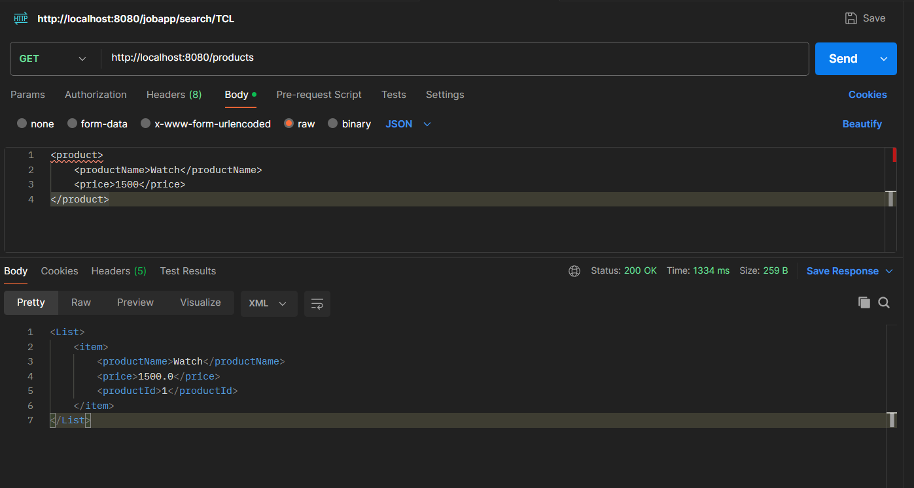

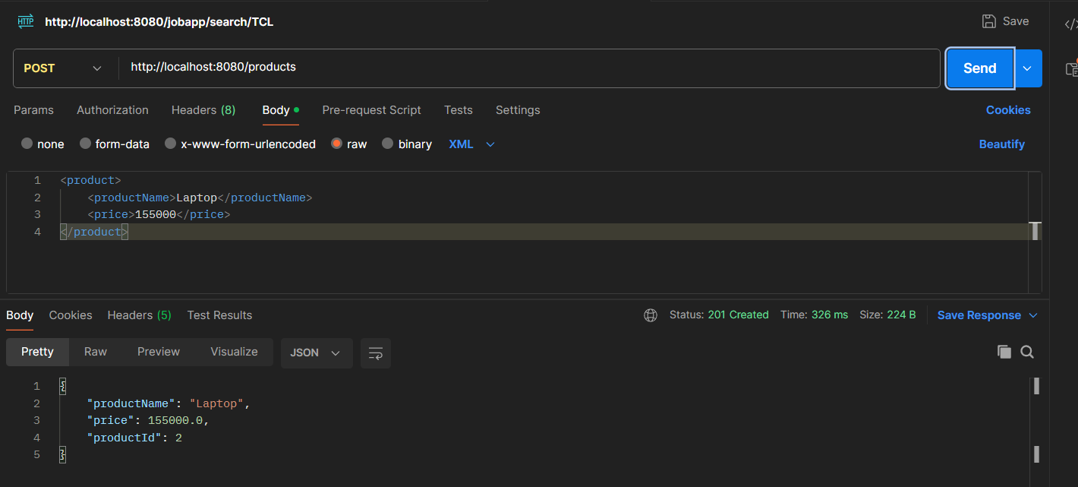

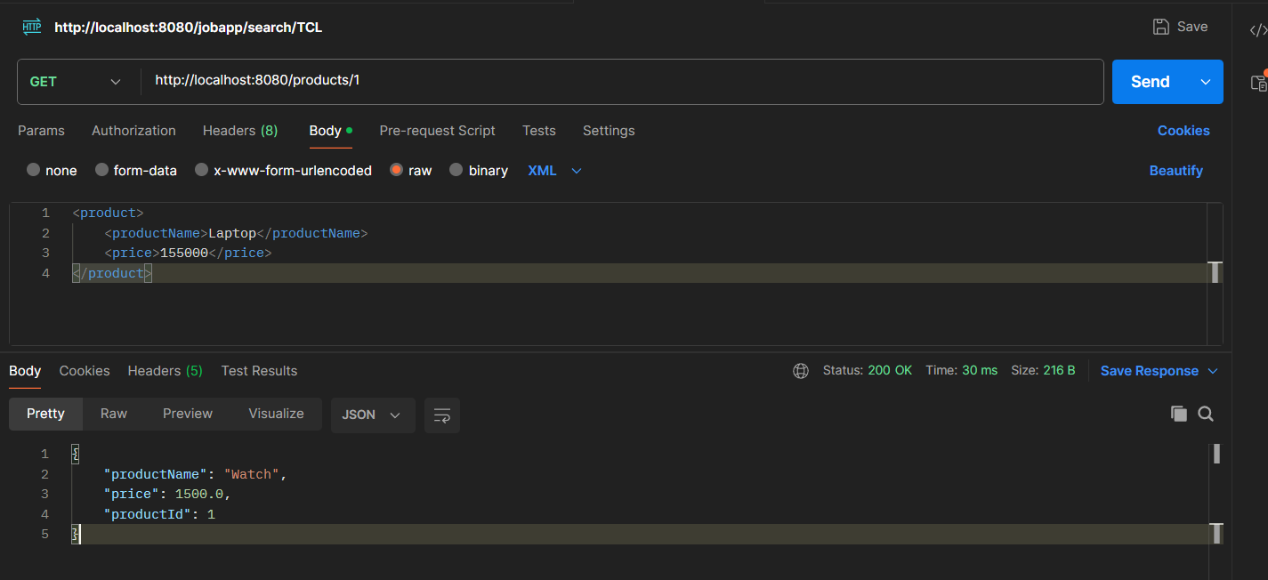

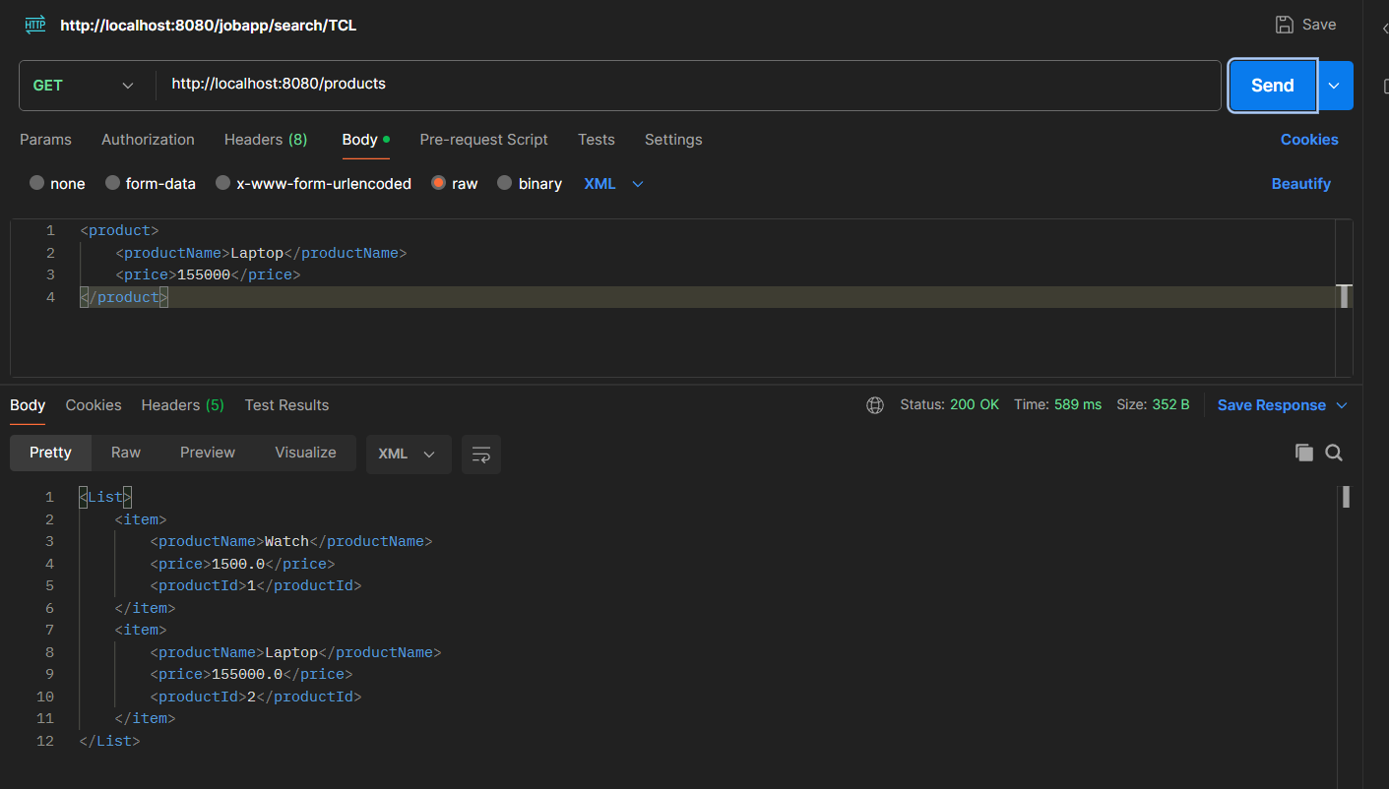

Capstone Challenge
Full Stack Employee Management System
Build a complete application using:
- Spring Boot REST API
- MySQL Database
- CRUD Operations
- PathVariable
- RequestBody
- PUT & DELETE Mapping
- Content Negotiation (JSON/XML)
- React Frontend
- Postman Testing
This project combines all concepts from REST Using Spring Boot Part 1 and Part 2 into a real-world full-stack application.

Solution:
Structure
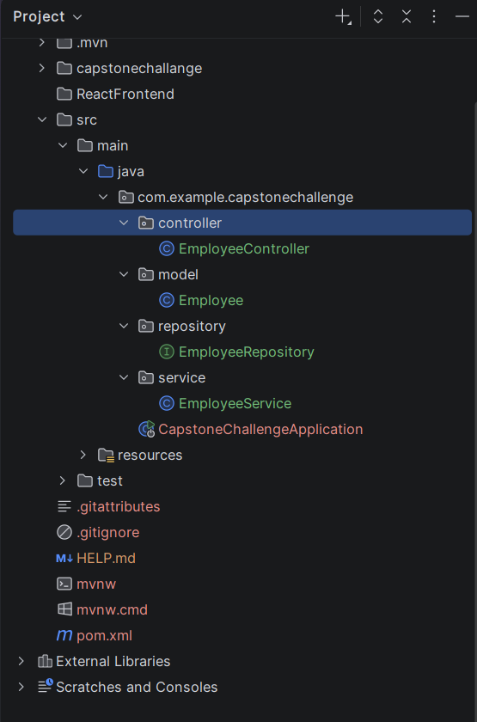
pom.xml
<?xml version="1.0" encoding="UTF-8"?>
<project xmlns="http://maven.apache.org/POM/4.0.0" xmlns:xsi="http://www.w3.org/2001/XMLSchema-instance"
xsi:schemaLocation="http://maven.apache.org/POM/4.0.0 https://maven.apache.org/xsd/maven-4.0.0.xsd">
<modelVersion>4.0.0</modelVersion>
<parent>
<groupId>org.springframework.boot</groupId>
<artifactId>spring-boot-starter-parent</artifactId>
<version>4.1.0</version>
<relativePath/> <!-- lookup parent from repository -->
</parent>
<groupId>com.example</groupId>
<artifactId>CapstoneChallenge</artifactId>
<version>0.0.1-SNAPSHOT</version>
<name>CapstoneChallenge</name>
<description>CapstoneChallenge</description>
<url/>
<licenses>
<license/>
</licenses>
<developers>
<developer/>
</developers>
<scm>
<connection/>
<developerConnection/>
<tag/>
<url/>
</scm>
<properties>
<java.version>21</java.version>
</properties>
<dependencies>
<dependency>
<groupId>org.springframework.boot</groupId>
<artifactId>spring-boot-starter-data-jpa</artifactId>
</dependency>
<dependency>
<groupId>org.springframework.boot</groupId>
<artifactId>spring-boot-starter-webmvc</artifactId>
</dependency>
<dependency>
<groupId>com.mysql</groupId>
<artifactId>mysql-connector-j</artifactId>
<scope>runtime</scope>
</dependency>
<dependency>
<groupId>org.springframework.boot</groupId>
<artifactId>spring-boot-starter-data-jpa-test</artifactId>
<scope>test</scope>
</dependency>
<dependency>
<groupId>org.springframework.boot</groupId>
<artifactId>spring-boot-starter-webmvc-test</artifactId>
<scope>test</scope>
</dependency>
<!-- Source: https://mvnrepository.com/artifact/tools.jackson.dataformat/jackson-dataformat-xml -->
<dependency>
<groupId>tools.jackson.dataformat</groupId>
<artifactId>jackson-dataformat-xml</artifactId>
<version>3.2.1</version>
<scope>compile</scope>
</dependency>
<!-- Source: https://mvnrepository.com/artifact/jakarta.xml.bind/jakarta.xml.bind-api -->
<dependency>
<groupId>jakarta.xml.bind</groupId>
<artifactId>jakarta.xml.bind-api</artifactId>
<version>4.0.5</version>
<scope>compile</scope>
</dependency>
</dependencies>
<build>
<plugins>
<plugin>
<groupId>org.springframework.boot</groupId>
<artifactId>spring-boot-maven-plugin</artifactId>
</plugin>
</plugins>
</build>
</project>

resources/application.properties
spring.application.name=CapstoneChallenge
spring.datasource.url=jdbc:mysql://localhost:3306/employeedb
spring.datasource.username=root
spring.datasource.password=root@123
spring.datasource.driver-class-name=com.mysql.cj.jdbc.Driver
spring.jpa.hibernate.ddl-auto=update
spring.jpa.properties.hibernate.dialect=org.hibernate.dialect.MySQLDialect
spring.jpa.show-sql=true
spring.jpa.properties.hibernate.format_sql=true

model/Employee.java
package com.example.capstonechallenge.model;
import jakarta.persistence.*;
import jakarta.xml.bind.annotation.XmlRootElement;
@Entity
@Table(name = "employees")
@XmlRootElement(name = "Employee")
public class Employee {
@Id
@GeneratedValue(strategy = GenerationType.IDENTITY)
private Long id;
private String name;
private String department;
private Double salary;
public Employee() {}
public Employee(String name, String department, Double salary) {
this.name = name;
this.department = department;
this.salary = salary;
}
public Long getId() { return id; }
public void setId(Long id) { this.id = id; }
public String getName() { return name; }
public void setName(String name) { this.name = name; }
public String getDepartment() { return department; }
public void setDepartment(String department) { this.department = department; }
public Double getSalary() { return salary; }
public void setSalary(Double salary) { this.salary = salary; }
}

controller/EmployeeController.java
package com.example.capstonechallenge.controller;
import com.example.capstonechallenge.model.Employee;
import com.example.capstonechallenge.service.EmployeeService;
import org.springframework.beans.factory.annotation.Autowired;
import org.springframework.http.HttpStatus;
import org.springframework.http.ResponseEntity;
import org.springframework.web.bind.annotation.*;
import java.util.List;
@RestController
@RequestMapping("/api/employees")
@CrossOrigin(origins = "*")
public class EmployeeController {
@Autowired
private EmployeeService employeeService;
@GetMapping(produces = {"application/json", "application/xml"})
public List<Employee> getAllEmployees() {
return employeeService.getAllEmployees();
}
@GetMapping(value = "/{id}", produces = {"application/json", "application/xml"})
public ResponseEntity<Employee> getEmployeeById(@PathVariable("id") Long id) {
return employeeService.getEmployeeById(id)
.map(ResponseEntity::ok)
.orElse(ResponseEntity.notFound().build());
}
@PostMapping(
consumes = {"application/json", "application/xml"},
produces = {"application/json", "application/xml"}
)
public ResponseEntity<Employee> createEmployee(@RequestBody Employee employee) {
Employee saved = employeeService.saveEmployee(employee);
return new ResponseEntity<>(saved, HttpStatus.CREATED);
}
@PutMapping(
value = "/{id}",
consumes = {"application/json", "application/xml"},
produces = {"application/json", "application/xml"}
)
public ResponseEntity<Employee> updateEmployee(@PathVariable("id") Long id, @RequestBody Employee employee) {
Employee updated = employeeService.updateEmployee(id, employee);
if (updated != null) {
return ResponseEntity.ok(updated);
}
return ResponseEntity.notFound().build();
}
@DeleteMapping("/{id}")
public ResponseEntity<Void> deleteEmployee(@PathVariable("id") Long id) {
if (employeeService.deleteEmployee(id)) {
return ResponseEntity.noContent().build();
}
return ResponseEntity.notFound().build();
}
}

service/EmployeeService.java
package com.example.capstonechallenge.service;
import com.example.capstonechallenge.model.Employee;
import com.example.capstonechallenge.repository.EmployeeRepository;
import org.springframework.beans.factory.annotation.Autowired;
import org.springframework.stereotype.Service;
import java.util.List;
import java.util.Optional;
@Service
public class EmployeeService {
@Autowired
private EmployeeRepository employeeRepository;
public List<Employee> getAllEmployees() {
return employeeRepository.findAll();
}
public Optional<Employee> getEmployeeById(Long id) {
return employeeRepository.findById(id);
}
public Employee saveEmployee(Employee employee) {
return employeeRepository.save(employee);
}
public Employee updateEmployee(Long id, Employee updatedData) {
return employeeRepository.findById(id).map(emp -> {
emp.setName(updatedData.getName());
emp.setDepartment(updatedData.getDepartment());
emp.setSalary(updatedData.getSalary());
return employeeRepository.save(emp);
}).orElse(null);
}
public boolean deleteEmployee(Long id) {
if (employeeRepository.existsById(id)) {
employeeRepository.deleteById(id);
return true;
}
return false;
}
}

repository/EmployeeRepository.java
package com.example.capstonechallenge.repository;
import com.example.capstonechallenge.model.Employee;
import org.springframework.data.jpa.repository.JpaRepository;
import org.springframework.stereotype.Repository;
@Repository
public interface EmployeeRepository extends JpaRepository<Employee, Long> {
}

CapstoneChallengeApplication.java
package com.example.capstonechallenge;
import org.springframework.boot.SpringApplication;
import org.springframework.boot.autoconfigure.SpringBootApplication;
@SpringBootApplication
public class CapstoneChallengeApplication {
public static void main(String[] args) {
SpringApplication.run(CapstoneChallengeApplication.class, args);
}
}

React UI: CaptoneProject.js
import React, { useState, useEffect } from 'react';
const API_URL = "http://localhost:8080/api/employees";
function CapstoneProject() {
const [employees, setEmployees] = useState([]);
const [formData, setFormData] = useState({ name: '', department: '', salary: '' });
const [editingId, setEditingId] = useState(null);
useEffect(() => {
fetchEmployees();
}, []);
const fetchEmployees = async () => {
try {
const response = await fetch(API_URL, {
headers: { 'Accept': 'application/json' }
});
const data = await response.json();
setEmployees(data);
} catch (error) {
console.error("Error fetching employees:", error);
}
};
const handleInputChange = (e) => {
setFormData({ ...formData, [e.target.name]: e.target.value });
};
const handleSubmit = async (e) => {
e.preventDefault();
const payload = {
name: formData.name,
department: formData.department,
salary: parseFloat(formData.salary)
};
try {
if (editingId) {
await fetch(`${API_URL}/${editingId}`, {
method: 'PUT',
headers: {
'Content-Type': 'application/json',
'Accept': 'application/json'
},
body: JSON.stringify(payload)
});
setEditingId(null);
} else {
await fetch(API_URL, {
method: 'POST',
headers: {
'Content-Type': 'application/json',
'Accept': 'application/json'
},
body: JSON.stringify(payload)
});
}
setFormData({ name: '', department: '', salary: '' });
fetchEmployees();
} catch (error) {
console.error("Error saving employee:", error);
}
};
const handleEdit = (emp) => {
setEditingId(emp.id);
setFormData({ name: emp.name, department: emp.department, salary: emp.salary });
};
const handleDelete = async (id) => {
try {
await fetch(`${API_URL}/${id}`, { method: 'DELETE' });
fetchEmployees();
} catch (error) {
console.error("Error deleting employee:", error);
}
};
return (
<div style={{ maxWidth: '800px', margin: '30px auto', fontFamily: 'Arial, sans-serif' }}>
<h2>Capstone: Employee Management System</h2>
<form onSubmit={handleSubmit} style={{ display: 'flex', gap: '10px', marginBottom: '20px' }}>
<input
type="text"
name="name"
placeholder="Employee Name"
value={formData.name}
onChange={handleInputChange}
required
/>
<input
type="text"
name="department"
placeholder="Department"
value={formData.department}
onChange={handleInputChange}
required
/>
<input
type="number"
name="salary"
placeholder="Salary"
value={formData.salary}
onChange={handleInputChange}
required
/>
<button type="submit">{editingId ? 'Update' : 'Add'}</button>
</form>
<table border="1" cellPadding="8" style={{ width: '100%', borderCollapse: 'collapse' }}>
<thead>
<tr>
<th>ID</th>
<th>Name</th>
<th>Department</th>
<th>Salary</th>
<th>Actions</th>
</tr>
</thead>
<tbody>
{employees.map((emp) => (
<tr key={emp.id}>
<td>{emp.id}</td>
<td>{emp.name}</td>
<td>{emp.department}</td>
<td>₹{emp.salary}</td>
<td>
<button onClick={() => handleEdit(emp)} style={{ marginRight: '5px' }}>Edit</button>
<button onClick={() => handleDelete(emp.id)}>Delete</button>
</td>
</tr>
))}
</tbody>
</table>
</div>
);
}
export default CapstoneProject;

Output:

